A Concise and Informative Title Reflecting the Core
Focus of the Study
First Author Name *, Second Author Name

Abstract
This abstract provides a concise summary of the research, highlighting the main objective, methodology, key findings, and conclusions. Begin by clearly stating the purpose or aim of the study. Briefly describe the methodology used, including any experimental design, analytical approach, or theoretical framework. Summarize the primary results and explain their significance. Conclude with a statement on the implications or potential applications of the research. The abstract should be written in a single paragraph and must not exceed 250 words. Avoid citations, figures, or overly technical details. Ensure it is understandable to readers outside your specific discipline while remaining technically accurate.
Keywords: keyword 1, keyword 2, keyword 3, keyword 4, keyword 5, keyword 6.

Introduction
The introduction sets the stage for the entire manuscript. It should begin with a clear and engaging presentation of the broader context of the research area. Authors are encouraged to provide background information that explains the significance of the study within its academic or practical field. For instance, load transfer mechanisms in slab-on-ground systems are critical for ensuring long-term pavement durability and structural integrity. Recent innovations in materials engineering have introduced alternatives such as fiber-reinforced polymers (FRPs) and stainless steel as promising solutions to corrosion-related deterioration.
Following the general background, the introduction should summarize existing work relevant to the present study ¹. This includes citing previous research findings and highlighting the current state of knowledge. Authors should then identify gaps, inconsistencies, or limitations in the literature that justify the need for the present research. For example, while traditional steel dowels have been widely studied, research on small-diameter FRP dowels in real-world applications remains limited ^{2,3}. Such gaps provide motivation for further investigation and highlight the novelty of the current work. Alvaro et al. ⁴ found that the bond strength of three different GFRP rebar types—sand-coated, helically grooved, and lugged—varied based on surface enhancement, but was not significantly affected by exposure time or temperature in seawater environments.
Next, the purpose and objectives of the current study should be clearly stated. Authors should define what their research aims to investigate or demonstrate and briefly mention the methodology used. This provides a logical transition from the literature background to the specific contribution of the current paper. A well-defined research objective helps readers understand the scope and importance of the study.
In some cases, authors may also choose to include a final paragraph outlining the structure of the paper, briefly describing what each subsequent section will address. To ensure proper citation and referencing throughout the manuscript, it is highly recommended that authors use reference management software such as Mendeley, Zotero, or EndNote ^{5,6}. Zotero was the reference manager used for referencing in this document. These tools support the Nature citation style required by the Journal of Undergraduate Research International and simplify the process of formatting in-text citations and the reference list. The introduction should be focused and concise, typically not exceeding 10% of the total word count of the paper.

Section 2 (e.g. Methodology)

Sub-section 1 (e.g., Materials and Experimental Program)
This section should provide a detailed description of the materials and preparation procedures used in the research. Authors are expected to specify the types, dimensions, and properties of materials selected for the study, including any distinguishing surface characteristics or treatments. Where applicable, include details such as classification, manufacturer, or production process ⁷. Any variations in material type, size, or configuration should be clearly described, and appropriately illustrated using figures.
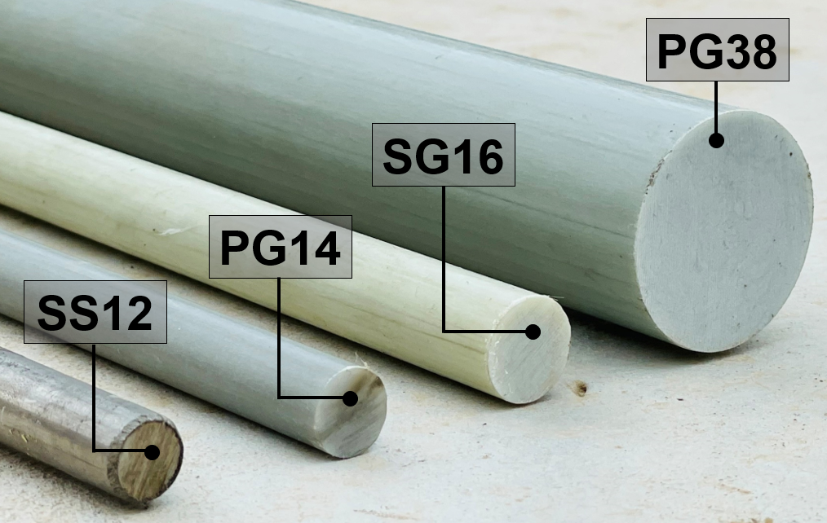
Figure 1. Dowel bars used in the study
Material properties should be summarized in a clear and concise manner using tables. Table 1 may include physical or mechanical properties such as diameter, strength, density, or surface texture. If additional materials (e.g., concrete, composites, or adhesives) were used in the study, their mix proportions and performance characteristics should be included, preferably in a second table.
Authors should also describe the standards followed for testing material properties, such as compressive or tensile strength tests ^{8,9}. Curing conditions, environmental controls, and any special treatment methods should be outlined to ensure reproducibility. Figure 1 shows the types of dowel bars used in the experimental program. The materials properties of the dowel bars are presented in Table 1. All figures and tables must be referred to in the text and embedded within the manuscript body, as per journal submission guidelines.
Table 1. Materials properties
Dowel bar name | PG14 | SG16 | PG38▲ | SS12
Material type | GFRP |  |  | Stainless-steel
Guaranteed tensile strength (MPa)* | 870.9 | 799.3 | 517 | 683 (f_{y})
Guaranteed transverse shear strength (MPa) * | 152.6 | 155.8 | 150 | 0.6 f_{y} = 410 MPa
Young’s modulus (GPa) | 48.4 | 47 | 46 | 199
Diameter (mm) | 13.7 | 16 | 38 | 12
Note: *Guaranteed strength for GFRP: Average strength - Thrice the standard deviation; ▲from the manufacturer’s technical data sheet

Sub-section 2 (e.g. Test prototypes and parameters)
This section should describe the test specimens or prototypes prepared for the experimental program. Authors should clearly define the design, dimensions, and configuration of each prototype used in the study. Where applicable, provide the number of specimens, their structural geometry, and any variations in key parameters between test groups ^{10–12}. Testing parameters should be outlined in detail, including loading type (e.g., static, dynamic, cyclic), loading rate, boundary conditions, support types, and measurement methods. The rationale behind the selected parameters should be briefly discussed to demonstrate their relevance to practical applications or theoretical modeling ⁵. Schematic diagram of test prototype constructed in the study is shown in Figure 2. The Sankey diagram of the test matrix is shown in Figure 3.
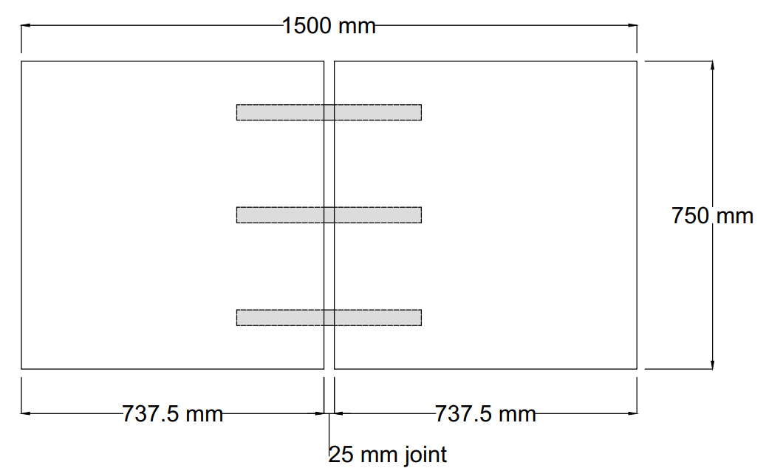  dowel | 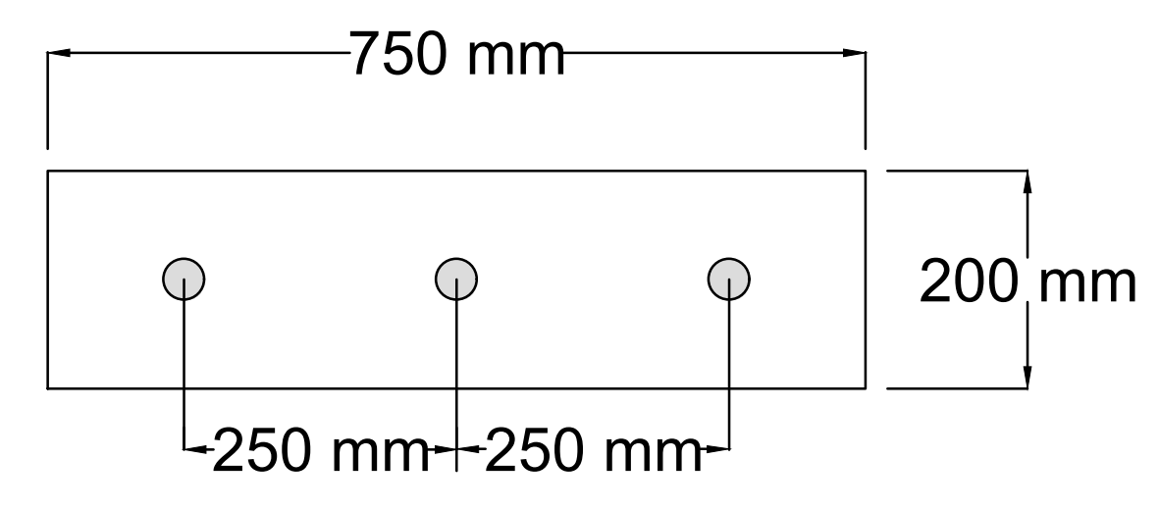
(a) Plan view | (b) Section-view at joint face
Figure 2. Schematic diagram of test prototype
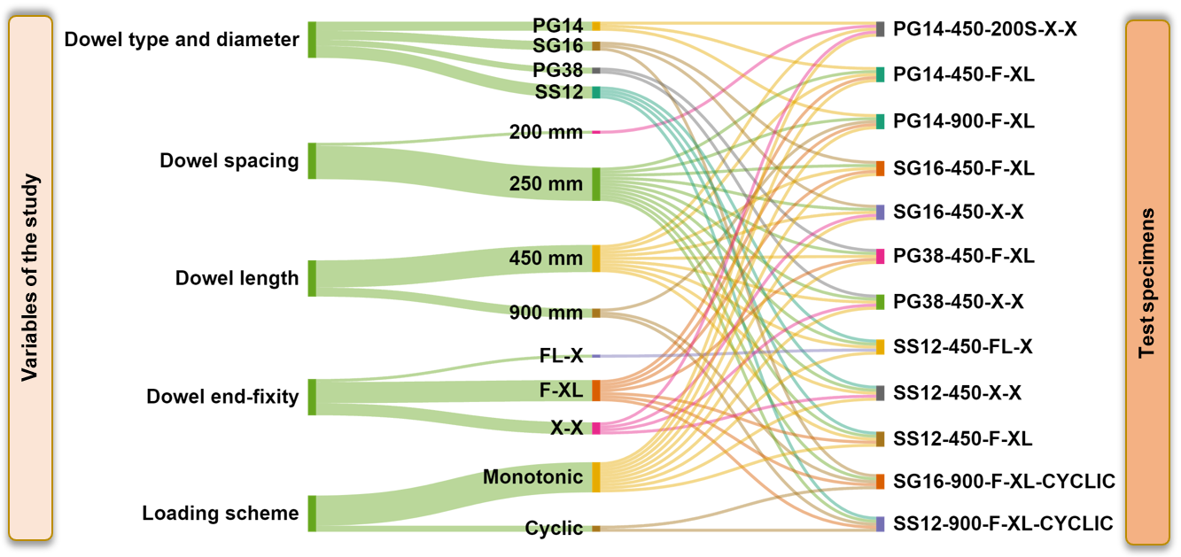
Figure 3. Sankey diagram: test matrix
Authors may also include schematics or photos of the test setup to support visual understanding. All instrumentation used to record data (e.g., displacement transducers, strain gauges, load cells) should be mentioned, along with the accuracy and calibration procedures, if relevant. Where multiple test series are included, a summary table (Table 2) may be used to present test variables, specimen identifiers, and parameter ranges ^{13,14}. This helps ensure clarity and allows for easy comparison between different test conditions. All prototypes should be labeled and referred to consistently throughout the manuscript to maintain traceability of results and discussion.
Table 2. Test Matrix
Sl. No. | Specimen ID | Dowel type | Dowel spacing (mm) | Dowel length (mm) | Dowel end-fixity | Loading scheme
1 | PG14-450-200S-X-X | PG14 | 200 | 450 | X-X | Monotonic
2 | PG14-450-F-XL | PG14 | 250 | 450 | F-XL | Monotonic
3 | PG14-900-F-XL | PG14 | 250 | 900 | F-XL | Monotonic
4 | SG16-450-F-XL | SG16 | 250 | 450 | F-XL | Monotonic
5 | SG16-450-X-X | SG16 | 250 | 450 | X-X | Monotonic
6 | PG38-450-F-XL | PG38 | 250 | 450 | F-XL | Monotonic
7 | PG38-450-X-X | PG38 | 250 | 450 | X-X | Monotonic
8 | SS12-450-FL-X | SS12 | 250 | 450 | FL-X | Monotonic
9 | SS12-450-X-X | SS12 | 250 | 450 | X-X | Monotonic
10 | SS12-450-F-XL | SS12 | 250 | 450 | F-XL | Monotonic
11 | SG16-900-F-XL-CYCLIC | SG16 | 250 | 900 | F-XL | Cyclic
12 | SS12-900-F-XL-CYCLIC | SS12 | 250 | 900 | F-XL | Cyclic

Section 3 (e.g. Experimental Work)
This section provides a detailed account of how the experimental procedures were implemented. It includes the layout and configuration of the test setup, the measurement tools used to capture response data, and the step-by-step loading procedures followed during testing.

Sub-section 1 (e.g. Test setup)
Authors should describe the physical arrangement of the test apparatus, including the placement of specimens, supports, and any external fixtures. Structural boundary conditions such as restraints, fixities, and load application points should be clearly specified ¹⁵. A schematic diagram or photograph is recommended to support the written description and to clarify the spatial configuration of the testing environment. Where applicable, dimensions of the testing frame, reaction system, or foundation support should be provided. Any custom-designed components or unique setup considerations should be noted to assist in replicability ¹⁶.

Sub-section 1 (e.g. Instrumentation)
This subsection should detail the measurement systems and sensors used to record experimental data. Common instrumentation may include load cells, linear variable differential transformers (LVDTs), strain gauges, displacement transducers, accelerometers, or data acquisition systems. For each instrument, indicate the measurement range, resolution, and location of placement on the test specimen or setup.
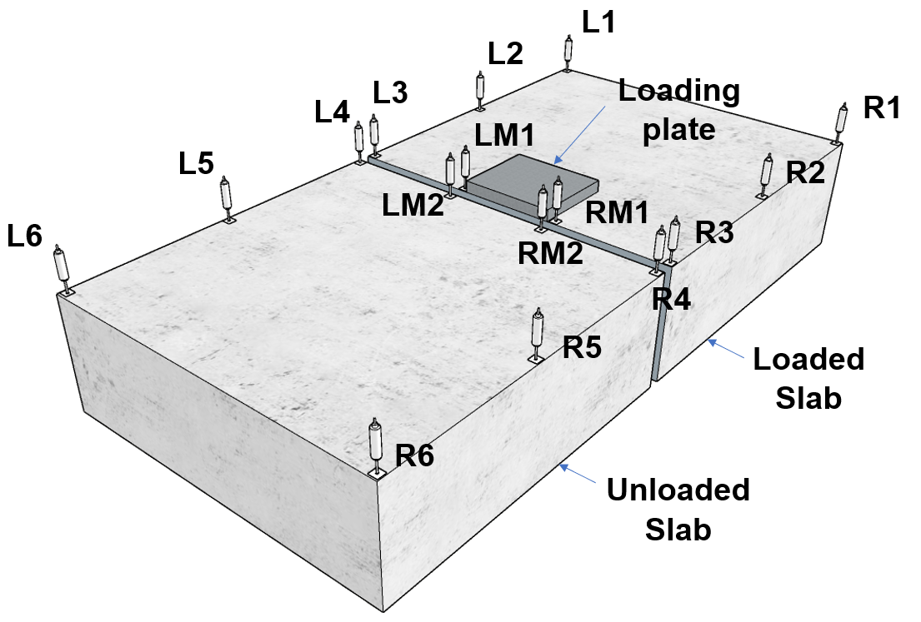 | 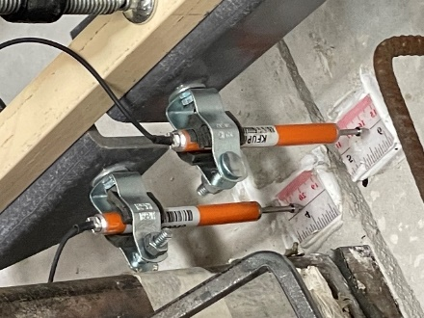
(a) | (b)
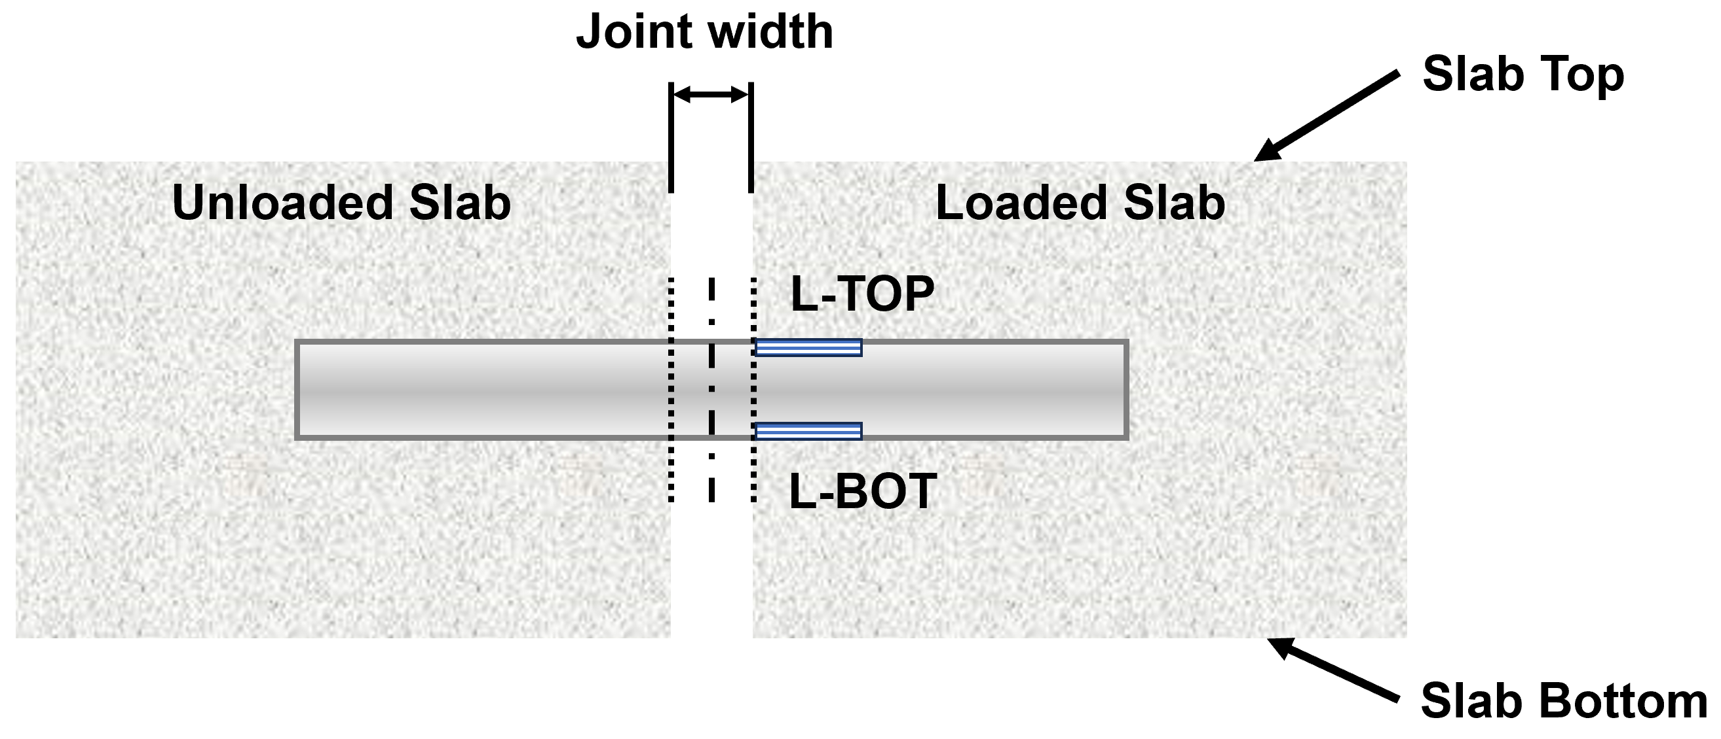 | 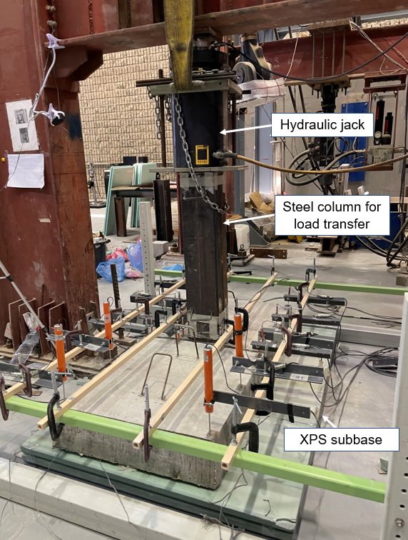
(c) | (d)
Figure 4. Load test of slab specimen with dowelled-joint resting on XPS-2 subbase: (a) Schematic of LVDT instrumentation; (b) LVDT at joint; (c) Strain gauges on the dowel bars; and (d) loaded specimen.
Calibration procedures, data logging frequency, and signal filtering methods should be mentioned where relevant. Authors are encouraged to present an instrumentation layout diagram if multiple sensors are involved. Figure 4 illustrates the instrumentation and setup used during the load testing of slab specimens with dowelled joints placed on an XPS-2 subbase. Figure 4 (a) shows the schematic layout of the test configuration, including the positioning of LVDTs across the joint to measure relative displacement and joint movement. Figure 4 (b) provides a close-up image of an LVDT installed at the joint, capturing real-time deflection during loading. Figure 4 (c) displays the strain gauges mounted on the dowel bars, which were used to monitor strain distribution and assess load transfer through the dowel. Finally, Figure 4 (d) presents the actual test setup during loading, showing the applied load and boundary conditions used in the experimental program.

Results and discussion
This section presents the key findings of the study and provides an in-depth discussion of the results in the context of the research objectives. The data should be interpreted clearly, with an emphasis on patterns, anomalies, and comparisons to existing literature. Figures and tables should be used to support the analysis and referenced appropriately within the text.

Subsection 1
This subsection provides a general overview of the experimental or analytical outcomes. Authors should begin by summarizing the main trends or response behaviors observed across all test groups or scenarios. This may include variations in load capacity, stiffness, deformation characteristics, or response time, depending on the nature of the study. Load-displacement curves of PG38-450-X-X is plotted in Figure 5. A typical equation is shown in Eq. 1.
$$u=\frac{1}{2}\left(ε_{0}{\left|\vec{E}\right|}^{2}+\frac{1}{μ_{0}}{\left|\vec{B}\right|}^{2}\right)+\int_{v_{1}}^{v_{2}}{\vec{J}⋅\vec{E}}dV-∇⋅\left(\vec{E}×\vec{B}\right)$$ | (1)
The results should be presented systematically, ensuring clarity and logical flow. Where applicable, reference to key metrics or performance indicators should be included. Authors may also use this section to introduce any unexpected results that will be further explained in later subsections.
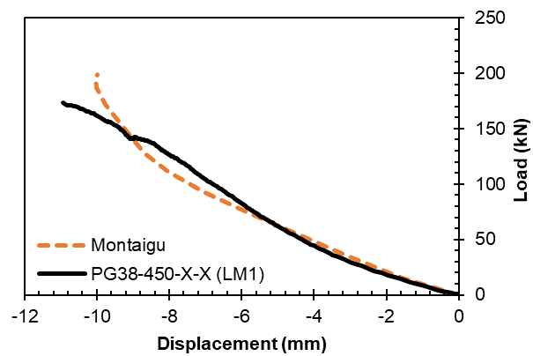
Figure 5. Load-displacement curves of PG38-450-X-X compared with results from Montaigu ¹⁷

Sub-subsection 1
Initial observations often provide insight into the fundamental behavior of the tested systems. Authors should describe how each test specimen or case responded under the initial loading or operational conditions. This includes stiffness response, initial cracking, deformation behavior, or stress distribution. These early results are often important in validating baseline assumptions and establishing comparability between different test cases or theoretical models.

Sub-subsection 1
Once basic trends are established, authors should compare the outcomes to previously published research or theoretical models. This helps in determining whether the current findings are consistent with existing knowledge or offer new insights. Differences between expected and observed behaviors should be discussed with possible explanations. Comparisons may also be made with design standards, empirical equations, or numerical simulations where applicable. Citing relevant sources using the Nature citation style is encouraged to support the discussion. The Initial and ultimate failure load capacities of specimens is shown in Figure 6.
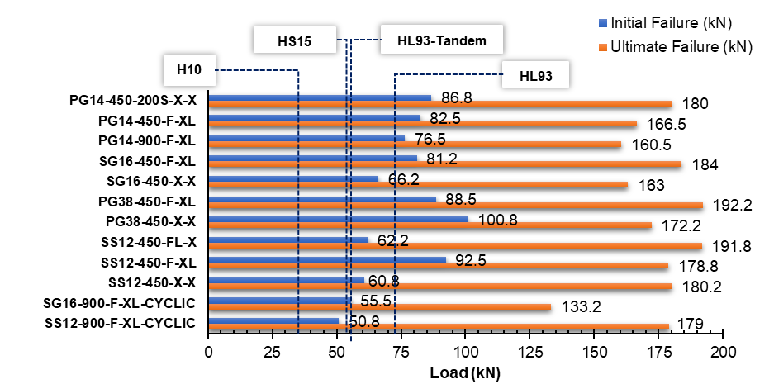
Figure 6. Initial and ultimate failure load capacities of specimens

Subsection 2
This subsection should explore how key experimental or analytical parameters influenced the overall results. The selection of parameters should be justified based on the objectives of the study and the trends observed. Results can be grouped and discussed based on material type, specimen dimensions, environmental conditions, or other relevant variables. Data visualizations (e.g., plots, charts, or comparative bar graphs) should be used to illustrate these relationships effectively. Figure 7 illustrates the failure modes observed in the slab specimens subjected to monotonic loading. Figure 7 (a) shows the unloaded PG14-450-F-XL slab after failure, highlighting the overall condition of the specimen post-testing. Figure 7 (b) presents a close-up of the PG14 dowel, which experienced shear failure. Figure 7 (c) captures the PG38-450-F-XL specimen during loading, showing the load application and visible surface response. Finally, Figure 7 (d) depicts the same PG38-450-F-XL slab in its unloaded state after failure, providing insight into the extent and nature of the structural damage.
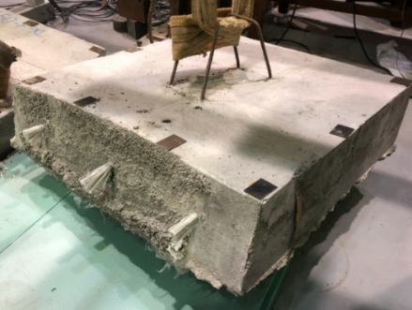 | 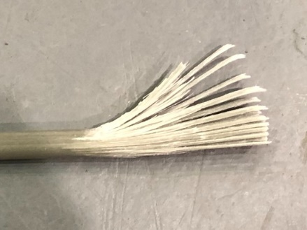
(a) | (b)
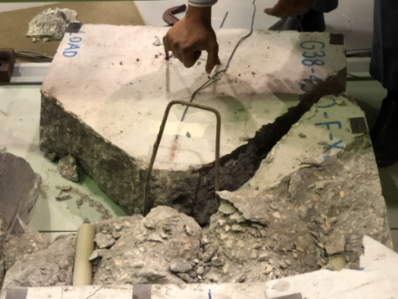 | 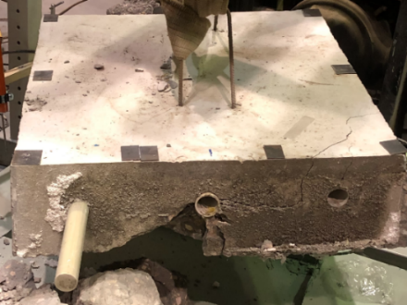
(c) | (d)
Figure 7. Failure in specimens under monotonic loads: (a) PG14-450-F-XL: unloaded slab after failure; (b) PG-14 dowel failed in shear; (c) PG38-450-F-XL: loaded slab; and (d) PG38-450-F-XL: unloaded slab.

Sub-subsection 1
Discuss how different material types or treatments affected the test outcomes. For example, variation in mechanical properties such as strength, stiffness, or ductility may lead to different load-bearing capacities or failure patterns. This sub-subsection should highlight the comparative performance of the materials and evaluate the suitability of each option for the intended application. Some equations are presented in Eqs. 2, 3, and 4.
$$E=\frac{2δ_{u}}{δ_{u}+δ_{l}}×100$$ | (2)
$$LTE=\frac{δ_{u}}{δ_{l}}×100$$ | (3)
$$Δ=δ_{l}-δ_{u}$$ | (4)
Here, δ_{u} is the unloaded slab deflection, and δ_{l} is the loaded slab deflection. For E and LTE, an efficiency of 100% indicates full transfer and 0% indicates no transfer at the joint between the loaded and unloaded slabs. The recommended joint effectiveness (E), according to ACPA is 75%, and the load transfer efficiency (LTE) recommended by AASHTO is 75%.
Where applicable, discuss the practical implications of using advanced or alternative materials in structural design or engineering systems.

Sub-subsection 2
Specimen geometry and test configuration often play a significant role in structural performance. Discuss how differences in size, shape, or boundary conditions influenced the experimental or simulation results. Authors should also evaluate how geometric changes affected factors such as stress distribution, crack propagation, or stability. Where feasible, include a critical analysis of whether these findings align with established design theories or standards. Figure 8 presents the influence of dowel bar diameter and material type on key performance indicators. Figure 8 (a) shows the load–deflection behavior for different dowel configurations, highlighting variations in stiffness and ultimate capacity. Figure 8 (b) illustrates the relative deflections across the joint, providing insight into the comparative displacement behavior under loading. Figure 8 (c) plots the joint effectiveness (E), reflecting the system's ability to maintain alignment and structural continuity. Lastly, Figure 8 (d) shows the load transfer efficiency (LTE), quantifying how effectively each dowel type distributes load across the joint interface.

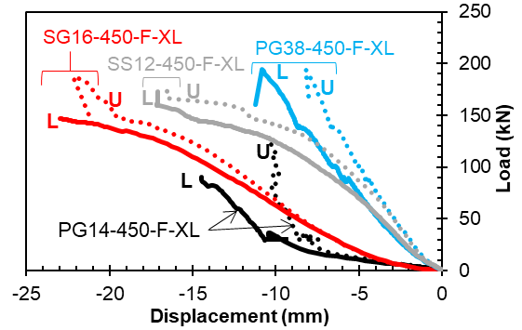 | 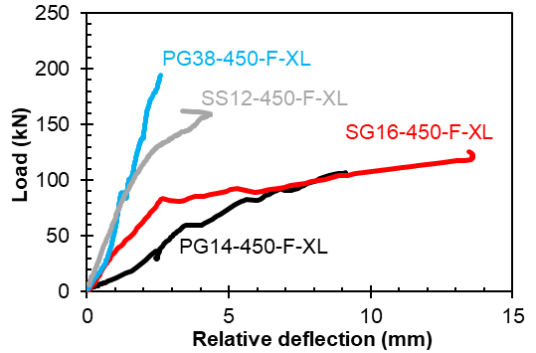
(a) | (b)
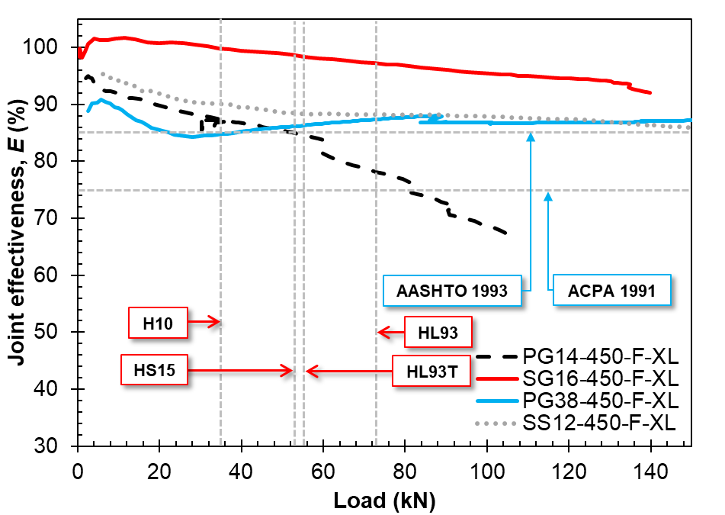 | 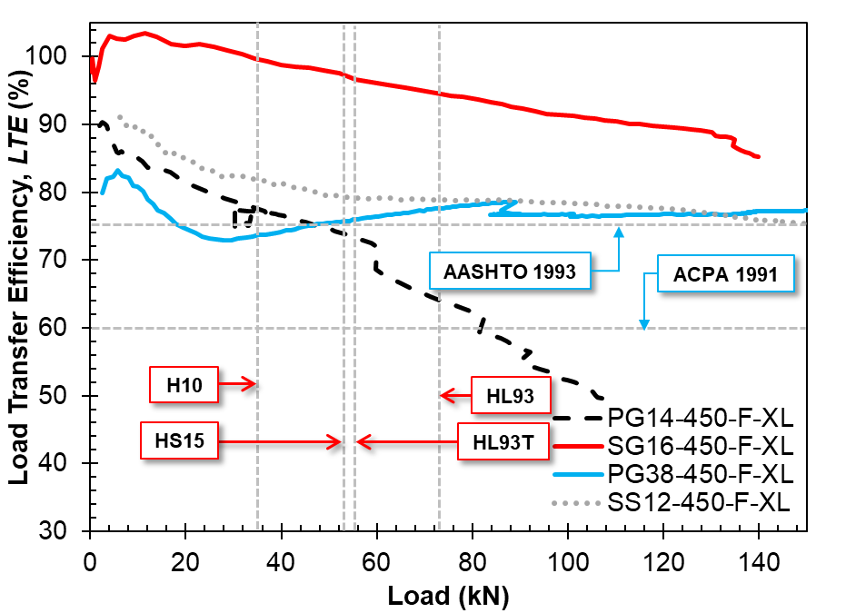
(c) | (d)
Figure 8. Effect of dowel bar diameter and material type: (a) Load-deflection plot; (b) relative deflections; (c) joint effectiveness, E; and (d) load transfer efficiency, LTE.
To uphold academic integrity and ensure originality in scholarly work, all submissions undergo similarity checks using plagiarism detection tools prior to acceptance. These checks are essential to identify unintentional overlaps with previously published literature and to maintain ethical standards in research dissemination. With the increasing accessibility of artificial intelligence tools, particularly large language models (LLMs) such as ChatGPT, researchers are reminded to use such technologies responsibly. While LLMs can support tasks like grammar refinement, language clarity, and idea structuring, the core intellectual content, analysis, and conclusions must remain the sole contribution of the authors.

Conclusions
This study investigated [insert brief statement about the study’s focus, e.g., the structural behavior of alternative dowel systems in slab-on-ground applications]. The research aimed to assess performance parameters such as strength, stiffness, deformation behavior, and failure modes under controlled loading conditions. Based on the experimental and/or analytical results, the following key conclusions can be drawn:
The test specimens exhibited consistent load–displacement behavior across different configurations, validating the experimental setup and methodology. [A few examples are given below]
- Material type significantly influenced the mechanical performance, with notable differences observed in peak load capacity and post-peak response.
- Geometric parameters such as diameter and spacing played a critical role in stress distribution and overall structural performance.
- Failure modes were primarily governed by failure patterns like shear cracking, surface spalling, or yielding, and varied depending on material and boundary conditions.
- The results showed reasonable agreement with existing literature, with peak load capacities varying within ±25% of reported values (ranging from 18 to 24 kN) and compressive strengths aligning within ±10% (approximately 22.5 to 27.5 MPa), offering new insight into the behavior of small-diameter non-metallic dowels.
- The findings support the potential use of small-diameter GFRP dowels as a viable alternative to traditional steel dowels in jointed concrete pavement applications, subject to further validation under real-world service conditions and long-term durability assessments.
The outcomes of this study contribute to the growing body of research focused on improving the durability and performance of modern structural systems. Future work may include long-term durability studies, field-scale testing, and computational modeling to generalize the findings and optimize design strategies.

Acknowledgements
The authors would like to acknowledge the support provided by the Department of Engineering and the Interdisciplinary Research Center at King Fahd University of Petroleum and Minerals. This research was funded by the under project no. SMPL-ENG-2025-123. The authors also extend their appreciation to the technical staff and laboratory team for their assistance in specimen preparation and testing.

References
- Al-Humeidawi, B. H. & Mandal, P. Experimental investigation on the combined effect of dowel misalignment and cyclic wheel loading on dowel bar performance in JPCP. Eng. Struct. 174, 256–266 (2018).
- Asbahan, R. E. & Vandenbossche, J. M. Effects of temperature and moisture gradients on slab deformation for jointed plain concrete pavements. J. Transp. Eng. 137, 563–570 (2011).
- Suo, L., Wang, B., Zheng, C. & Ma, B. Dowels and load transfer across transverse joints of concrete surface in rigid pavement. Proc. Int. Conf. Transp. Dev. 2013, 1856–1861 (2013).
- Harvey, J. et al. Construction and test results from dowel bar retrofit HVS test sections 553FD, 554FD, and 555FD: US 101, Ukiah, Mendocino County. California Department of Transportation (2003).
- William, G. W. & Shoukry, S. N. 3D finite element analysis of temperature‐induced stresses in dowel jointed concrete pavements. Int. J. Geomech. 1, 291–307 (2001).
- Benmokrane, B., Ahmed, E. A., Montaigu, M. & Thebeau, D. Performance of glass fiber-reinforced polymer-doweled jointed plain concrete pavement under static and cyclic loadings. ACI Struct. J. 111, 331–342 (2014).
- Anderson, K. W. et al. Glass fiber reinforced polymer dowel bar evaluation. Washington State Department of Transportation (2012).
- Murison, S., Shalaby, A. & Mufti, A. Concrete-filled, glass fiber–reinforced polymer dowels for load transfer in jointed rigid pavements. Transp. Res. Rec. 1919, 54–64 (2005).
- Nanni, A., De Luca, A. & Jawaheri Zadeh, H. Reinforced concrete with FRP bars. CRC Press (2014).
- Zeng, J.-J. et al. Bond behavior between GFRP bars and seawater sea-sand fiber-reinforced ultra-high strength concrete. Eng. Struct. 254, 113787 (2022).
- Al-Humeidawi, B. H. & Mandal, P. Numerical evaluation of the combined effect of dowel misalignment and wheel load on dowel bars performance in JPCP. Eng. Struct. 252, 113655 (2022).
- Al-Humeidawi, B. H. & Mandal, P. Evaluation of performance and design of GFRP dowels in jointed plain concrete pavement – Part 1: Experimental investigation. Int. J. Pavement Eng. 15, 449–459 (2014).
- Löfsjögård, M. A laboratory investigation on bonding properties of dowels in concrete roads. Mater. Struct. 38, 721–728 (2005).
- Porter, M. L. et al. Investigation of glass fiber composite dowel bars for highway pavement slabs. Iowa Highway Research Board (2001).
- Shalaby, A. & Murison, S. Using fiber-reinforced polymer load transfer devices in jointed concrete pavements. Proc. Transp. Conf., Orlando, FL, USA (2001).

Undergraduate Author, Department of __________, King Fahd University of Petroleum & Minerals, Dhahran 31261, Saudi Arabia. (*Corresponding Author; Email: u20*******@kfupm.edu.sa; ORCID XXXX-XXXX-XXXX-XXXX).
Research Mentor, Professor, Department of __________, King Fahd University of Petroleum & Minerals, Dhahran 31261, Saudi Arabia. (Email: author.email@kfupm.edu.sa; ORCID XXXX-XXXX-XXXX-XXXX).

