Table S1 List of species of Dendrobium used in the molecular study for markers Xdh, ITS, trnL-trnF including Accession Number and GenBank Accession Number.
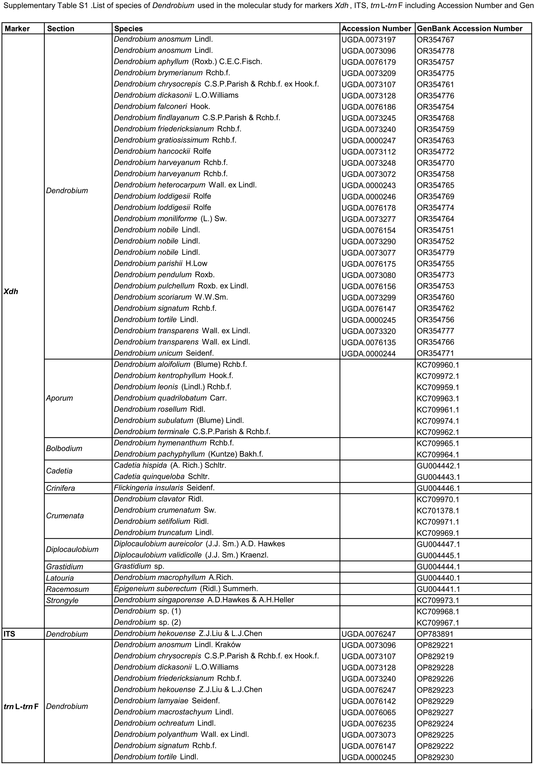

Table S2 List of species of Dendrobium used in the molecular study for markers ITS, trnL-trnF, matK including GenBank Accession Number.


