Supplementary material

Table S1 GBIF datasets of the localities of the species studied (incl. synonyms) and final number of records used in ENM analyses.
Species | GBIF dataset | Initial (number of records) in dataset | Final (number of records) in dataset
Cymbidium kanran | https://www.gbif.org/occurrence/download/0173848-210914110416597 | 186 | 35
Russula cyanoxantha | https://www.gbif.org/occurrence/download/0173849-210914110416597 | 27267 | 81
Epipogium roseum | https://www.gbif.org/occurrence/download/0173846-210914110416597 | 647 | 15
Coprinellus disseminatus | https://www.gbif.org/occurrence/download/0173847-210914110416597 | 16713 | 144

Table S2 Records of orchids and their symbionts used in the ENM analyses.
Species | Decimal Longitude | Decimal Latitude
Coprinellus disseminatus | 121,174767 | 24,082858
Coprinellus disseminatus | 120,973808 | 24,227187
Coprinellus disseminatus | 121,369178 | 24,400383
Coprinellus disseminatus | 121,437753 | 24,710668
Coprinellus disseminatus | 114,823102 | 4,023453
Coprinellus disseminatus | 145,46987 | -37,949134
Coprinellus disseminatus | 145,573651 | -37,684394
Coprinellus disseminatus | 138,669724 | -35,01593
Coprinellus disseminatus | 150,986814 | -33,380351
Coprinellus disseminatus | 110,401447 | 1,353594
Coprinellus disseminatus | 120,63092 | 23,599967
Coprinellus disseminatus | 121,672797 | 24,896228
Coprinellus disseminatus | 146,542861 | -41,186111
Coprinellus disseminatus | 146,567876 | -38,426218
Coprinellus disseminatus | 145,888782 | -37,667363
Coprinellus disseminatus | 148,366436 | -37,663775
Coprinellus disseminatus | 117,575837 | -34,796997
Coprinellus disseminatus | 151,252648 | -33,438053
Coprinellus disseminatus | 146,763585 | -19,311619
Coprinellus disseminatus | 121,737312 | 24,639472
Coprinellus disseminatus | 121,115867 | 24,687028
Coprinellus disseminatus | 147,274995 | -42,895672
Coprinellus disseminatus | 147,945525 | -40,041131
Coprinellus disseminatus | 145,039122 | -38,393417
Coprinellus disseminatus | 141,751175 | -38,117419
Coprinellus disseminatus | 146,230392 | -38,071005
Coprinellus disseminatus | 145,159181 | -37,870755
Coprinellus disseminatus | 144,906106 | -37,83065
Coprinellus disseminatus | 140,858884 | -37,805723
Coprinellus disseminatus | 144,294067 | -37,504362
Coprinellus disseminatus | 117,849192 | -34,681784
Coprinellus disseminatus | 115,081436 | -33,948508
Coprinellus disseminatus | 153,026235 | -27,482831
Coprinellus disseminatus | 100,264045 | 5,421088
Coprinellus disseminatus | 121,444412 | 24,958283
Coprinellus disseminatus | 103,822402 | 1,360427
Coprinellus disseminatus | 117,755622 | 5,0261
Coprinellus disseminatus | 120,76986 | 24,49849
Coprinellus disseminatus | 152,69057 | -26,62305
Coprinellus disseminatus | 140,007553 | 35,946445
Coprinellus disseminatus | 145,961253 | -41,407712
Coprinellus disseminatus | 117,329491 | -35,00245
Coprinellus disseminatus | 151,157301 | -33,806815
Coprinellus disseminatus | 152,76349 | -27,330027
Coprinellus disseminatus | 61,288814 | 55,192006
Coprinellus disseminatus | 69,395713 | 56,179022
Coprinellus disseminatus | 101,254713 | 21,929739
Coprinellus disseminatus | 82,928803 | 54,980914
Coprinellus disseminatus | 145,999328 | -37,892422
Coprinellus disseminatus | 142,296596 | -37,873092
Coprinellus disseminatus | 150,27356 | -33,650806
Coprinellus disseminatus | 145,584458 | -17,353747
Coprinellus disseminatus | 145,201431 | -38,158753
Coprinellus disseminatus | 77,58687 | 13,079896
Coprinellus disseminatus | 151,764861 | -32,926861
Coprinellus disseminatus | 145,568408 | -38,387847
Coprinellus disseminatus | 150,179942 | -35,718186
Coprinellus disseminatus | 74,836292 | 12,881216
Coprinellus disseminatus | 101,99173 | 19,749433
Coprinellus disseminatus | 149,083298 | -35,256721
Coprinellus disseminatus | 121,19697 | 22,793883
Coprinellus disseminatus | 120,503857 | 23,270289
Coprinellus disseminatus | 114,049695 | 22,540637
Coprinellus disseminatus | 143,914001 | -38,507384
Coprinellus disseminatus | 146,744637 | -43,047835
Coprinellus disseminatus | 101,633207 | 3,13928
Coprinellus disseminatus | 106,261033 | 17,540608
Coprinellus disseminatus | 120,709678 | 24,252047
Coprinellus disseminatus | 143,493354 | -38,671305
Coprinellus disseminatus | 153,354917 | -29,398437
Coprinellus disseminatus | 75,879425 | 11,16254
Coprinellus disseminatus | 65,665022 | 57,08523
Coprinellus disseminatus | 151,103893 | -34,041351
Coprinellus disseminatus | 84,946724 | 56,470348
Coprinellus disseminatus | 147,183342 | -43,216657
Coprinellus disseminatus | 145,562778 | -42,065556
Coprinellus disseminatus | 142,030278 | -37,7375
Coprinellus disseminatus | 142,5025 | -37,3725
Coprinellus disseminatus | 148,43 | -36,7319
Coprinellus disseminatus | 149,812466 | -35,644682
Coprinellus disseminatus | 149,962097 | -34,314828
Coprinellus disseminatus | 152,478754 | -31,208137
Coprinellus disseminatus | 145,6975 | -16,925833
Coprinellus disseminatus | 146,163483 | -38,674125
Coprinellus disseminatus | 72,419665 | 57,175652
Coprinellus disseminatus | 71,800676 | 57,252249
Coprinellus disseminatus | 116,009286 | -32,790162
Coprinellus disseminatus | 144,519123 | -38,260384
Coprinellus disseminatus | 73,379289 | 61,24889
Coprinellus disseminatus | 146,336923 | -39,019797
Coprinellus disseminatus | 153,104494 | -28,2
Coprinellus disseminatus | 153,193889 | -27,925833
Coprinellus disseminatus | 151,9319 | -27,579466
Coprinellus disseminatus | 152,094961 | -26,859245
Coprinellus disseminatus | 105,704306 | -10,454139
Coprinellus disseminatus | 145,790487 | -36,805374
Coprinellus disseminatus | 170,572939 | -45,888925
Coprinellus disseminatus | 65,683983 | 57,374721
Coprinellus disseminatus | 141,496356 | 43,056498
Coprinellus disseminatus | 145,751972 | -37,355705
Coprinellus disseminatus | 120,811758 | 21,958607
Coprinellus disseminatus | 108,19993 | -7,260878
Coprinellus disseminatus | 113,388038 | 23,180523
Coprinellus disseminatus | 133,094982 | 42,993042
Coprinellus disseminatus | 117,313326 | -8,574226
Coprinellus disseminatus | 77,176756 | 9,647078
Coprinellus disseminatus | 115,476208 | -33,604441
Coprinellus disseminatus | 153,401693 | -28,234771
Coprinellus disseminatus | 102,095974 | 20,720105
Coprinellus disseminatus | 107,569299 | -6,782639
Coprinellus disseminatus | 65,319865 | 56,91218
Coprinellus disseminatus | 146,57268 | -41,454323
Coprinellus disseminatus | 152,38337 | -28,050603
Coprinellus disseminatus | 142,857231 | -37,161032
Coprinellus disseminatus | 147,849999 | -42,699987
Coprinellus disseminatus | 146,7 | -42,683323
Coprinellus disseminatus | 146,782043 | -41,683044
Coprinellus disseminatus | 146,916674 | -41,349991
Coprinellus disseminatus | 142,962222 | -38,173333
Coprinellus disseminatus | 144,611944 | -37,378889
Coprinellus disseminatus | 140,7 | -37,35
Coprinellus disseminatus | 144,453889 | -37,143889
Coprinellus disseminatus | 146,305556 | -37,127778
Coprinellus disseminatus | 146,813889 | -36,333889
Coprinellus disseminatus | 150,142222 | -35,991111
Coprinellus disseminatus | 115,822222 | -31,984722
Coprinellus disseminatus | 153,066667 | -30,333333
Coprinellus disseminatus | 152,2 | -27,35
Coprinellus disseminatus | 151,594485 | -26,873937
Coprinellus disseminatus | 135,74182 | 34,65418
Coprinellus disseminatus | 135,75571 | 35,02207
Coprinellus disseminatus | 82,30072 | 53,22306
Coprinellus disseminatus | 146,866667 | -43,416664
Coprinellus disseminatus | 147,933329 | -43,15
Coprinellus disseminatus | 147,033336 | -42,866666
Coprinellus disseminatus | 146,266669 | -42,833335
Coprinellus disseminatus | 147,266664 | -42,616665
Coprinellus disseminatus | 148,283337 | -42,166664
Coprinellus disseminatus | 146,199996 | -41,700004
Coprinellus disseminatus | 148,166665 | -41,533334
Coprinellus disseminatus | 147,950003 | -41,21667
Coprinellus disseminatus | 147,616663 | -41,099997
Coprinellus disseminatus | 145,666664 | -40,999999
Coprinellus disseminatus | 144,849999 | -40,949996
Russula cyanoxantha | 136,77133 | 36,15356
Russula cyanoxantha | 139,145833 | 36,524722
Russula cyanoxantha | 137,82016 | 35,71583
Russula cyanoxantha | 130,60245 | 30,36236
Russula cyanoxantha | 121,276726 | 24,390162
Russula cyanoxantha | 121,52829 | 24,495405
Russula cyanoxantha | 120,978828 | 24,219278
Russula cyanoxantha | 121,289376 | 24,135139
Russula cyanoxantha | 81,45149 | 54,10842
Russula cyanoxantha | 82,61666 | 52,76666
Russula cyanoxantha | 145,17097 | 44,02831
Russula cyanoxantha | 141,40619 | 42,77356
Russula cyanoxantha | 143,96202 | 43,01089
Russula cyanoxantha | 141,80438 | 43,05192
Russula cyanoxantha | 144,24702 | 43,45053
Russula cyanoxantha | 140,98483 | 40,65833
Russula cyanoxantha | 139,79845 | 41,35461
Russula cyanoxantha | 141,48772 | 39,60911
Russula cyanoxantha | 140,88458 | 39,95592
Russula cyanoxantha | 140,47931 | 38,24942
Russula cyanoxantha | 140,71851 | 38,26386
Russula cyanoxantha | 141,51259 | 38,29603
Russula cyanoxantha | 140,10789 | 38,64994
Russula cyanoxantha | 136,72989 | 37,22114
Russula cyanoxantha | 137,04744 | 37,27478
Russula cyanoxantha | 139,92981 | 37,66212
Russula cyanoxantha | 138,34944 | 37,9152
Russula cyanoxantha | 138,19467 | 36,64853
Russula cyanoxantha | 138,755 | 36,109444
Russula cyanoxantha | 140,05746 | 36,13111
Russula cyanoxantha | 139,14137 | 36,13879
Russula cyanoxantha | 136,62944 | 36,19111
Russula cyanoxantha | 140,56073 | 36,19986
Russula cyanoxantha | 136,38438 | 36,27295
Russula cyanoxantha | 138,778889 | 36,296944
Russula cyanoxantha | 138,39152 | 36,321344
Russula cyanoxantha | 136,6209 | 36,3797
Russula cyanoxantha | 140,24931 | 36,38967
Russula cyanoxantha | 138,678889 | 36,538333
Russula cyanoxantha | 139,36816 | 36,599585
Russula cyanoxantha | 138,49069 | 36,70539
Russula cyanoxantha | 138,70778 | 36,74178
Russula cyanoxantha | 140,36012 | 36,77835
Russula cyanoxantha | 140,73969 | 36,80775
Russula cyanoxantha | 139,190556 | 36,809722
Russula cyanoxantha | 139,379444 | 36,823056
Russula cyanoxantha | 138,62402 | 37,09505
Russula cyanoxantha | 135,5506 | 35,27222
Russula cyanoxantha | 139,0705 | 35,14295
Russula cyanoxantha | 140,009256 | 35,169978
Russula cyanoxantha | 140,196733 | 35,586589
Russula cyanoxantha | 139,72298 | 35,63631
Russula cyanoxantha | 139,45044 | 35,72528
Russula cyanoxantha | 139,25803 | 35,79903
Russula cyanoxantha | 139,58638 | 35,94188
Russula cyanoxantha | 139,97456 | 35,94305
Russula cyanoxantha | 138,50348 | 35,96378
Russula cyanoxantha | 139,364199 | 36,0686
Russula cyanoxantha | 135,42566 | 34,4105
Russula cyanoxantha | 135,79257 | 34,50962
Russula cyanoxantha | 135,52061 | 34,61282
Russula cyanoxantha | 135,33189 | 34,7746
Russula cyanoxantha | 135,67795 | 34,93017
Russula cyanoxantha | 131,36163 | 34,04914
Russula cyanoxantha | 129,33167 | 34,61953
Russula cyanoxantha | 130,83447 | 31,10006
Russula cyanoxantha | 128,9162 | 27,75664
Russula cyanoxantha | 129,44383 | 28,28356
Russula cyanoxantha | 100,039612 | 26,70766
Russula cyanoxantha | 105,57078 | -10,489
Russula cyanoxantha | 135,20189 | -12,93256
Russula cyanoxantha | 132,81905 | -12,86537
Russula cyanoxantha | 143,31441 | -12,78234
Russula cyanoxantha | 132,479208 | -12,678589
Russula cyanoxantha | 135,81029 | -12,50916
Russula cyanoxantha | 132,453114 | -13,521618
Russula cyanoxantha | 134,50615 | -13,52115
Russula cyanoxantha | 135,77629 | -13,40822
Russula cyanoxantha | 132,336477 | -13,296442
Russula cyanoxantha | 130,794355 | -13,179121
Russula cyanoxantha | 135,71916 | -14,195246
Cymbidium kanran | 102,058 | 29,5997
Cymbidium kanran | 98,66582 | 27,740736
Cymbidium kanran | 120,66 | 22,66
Cymbidium kanran | 120,7 | 22,966667
Cymbidium kanran | 121,328889 | 23,155556
Cymbidium kanran | 126,985518 | 37,266851
Cymbidium kanran | 106,842041 | 32,352911
Cymbidium kanran | 103,398589 | 29,496119
Cymbidium kanran | 118,035307 | 27,756659
Cymbidium kanran | 100,222124 | 25,584234
Cymbidium kanran | 109,592453 | 25,635742
Cymbidium kanran | 110,040007 | 25,742153
Cymbidium kanran | 121,497084 | 24,859007
Cymbidium kanran | 106,633387 | 24,392902
Cymbidium kanran | 113,987821 | 24,399048
Cymbidium kanran | 113,604544 | 24,682731
Cymbidium kanran | 112,377423 | 24,780744
Cymbidium kanran | 113,184435 | 24,813781
Cymbidium kanran | 110,451522 | 24,846283
Cymbidium kanran | 113,217309 | 25,22845
Cymbidium kanran | 110,050532 | 25,255089
Cymbidium kanran | 104,250727 | 23,363
Cymbidium kanran | 104,672252 | 23,437468
Cymbidium kanran | 110,462487 | 23,519195
Cymbidium kanran | 121,479722 | 23,562778
Cymbidium kanran | 110,991129 | 24,095943
Cymbidium kanran | 110,235565 | 24,175587
Cymbidium kanran | 111,031652 | 22,446542
Cymbidium kanran | 106,66666 | 22,68333
Cymbidium kanran | 103,687613 | 22,983563
Cymbidium kanran | 106,288701 | 23,160603
Cymbidium kanran | 105,822072 | 23,258134
Cymbidium kanran | 101,56752 | 21,475834
Cymbidium kanran | 116,562386 | 11,318545
Epipogium roseum | 120,711284 | 23,247712
Epipogium roseum | 120,790367 | 23,636542
Epipogium roseum | 121,275171 | 24,750856
Epipogium roseum | 153,413437 | -28,941237
Epipogium roseum | 121,51645 | 25,179782
Epipogium roseum | 152,881767 | -31,4907
Epipogium roseum | 139,536534 | 35,502
Epipogium roseum | 115,425337 | 3,179295
Epipogium roseum | 75,927058 | 11,865572
Epipogium roseum | 73,794275 | 16,937524
Epipogium roseum | 77,176922 | 9,647466
Epipogium roseum | 152,177955 | -32,331274
Epipogium roseum | 120,262672 | 22,650349
Epipogium roseum | 83,938548 | 28,253008
Epipogium roseum | 152,8333 | -31,1

Table S3 Pearsons' correlation coefficient computed for 19 bioclimatic variables.

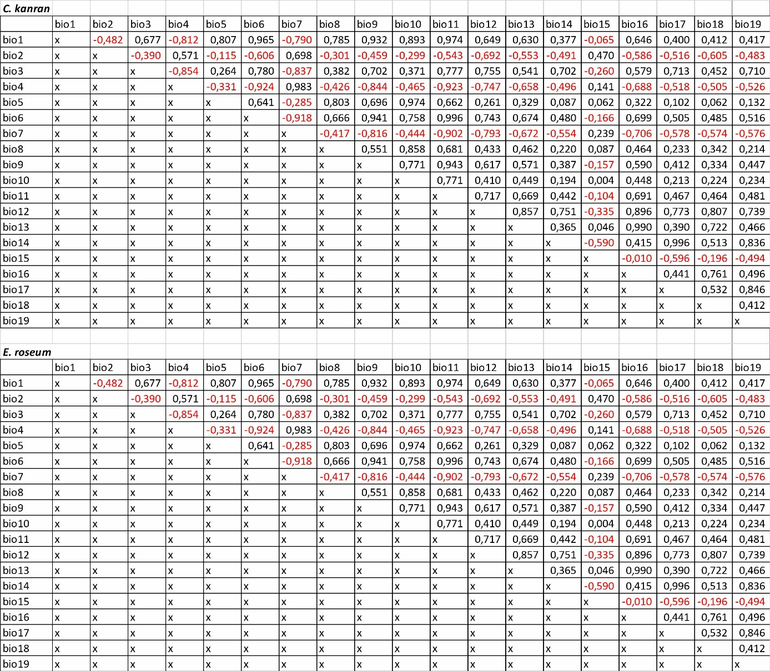
Table S4 Results of the AUC and TSS tests and values of Max Kappa for all models (SD = standard deviation).
Species | Dataset | AUC | TSS | Max Kappa
Cymbidium kanran | bioclims + fungus | 0.984 (SD=0.004) | 0.847 | 0.447
Cymbidium kanran | bioclims | 0.982 (SD=004) | 0.863 | 0.452
Russula cyanoxantha | bioclims | 0.974 (SD=0.006) | 0.818 | 0.425
Epipogium roseum | bioclims + fungus | 0.985 (SD=0.007) | 0.917 | 0.455
Epipogium roseum | bioclims | 0.964 (SD=0.013) | 0.792 | 0.434
Coprinellus disseminatus | bioclims | 0.964 (SD=0.004) | 0.781 | 0.416

Figure S1 Changes in the distribution of suitable niches for orchid symbiotic fungi R. cyanoxantha (A-D) and C. disseminatus (E-H) under various climate change scenarios - SSP1-2.6 (A, E), SSP2-4.5 (B, F), SSP3-7.0 (C, G) and SSP5-8.5 (D, H). Legend: 1 – range expansion, 0 – no occurrence, 1 – no range change, 2 – range contraction.

Figure S2 Differences in predictions of models of the distribution of suitable niches for C. kanran (A-E) and E. roseum (F-J) when fungal data are added to climate data. SSP1-2.6 (A, F), SSP2-4.5 (B, G), SSP3-7.0 (C, H) and SSP5-8.5 (D, I), present time (E-J). Legend: 1 – range expansion, 0 – no occurrence, 1 – no range change, 2 – range contraction.

Figure S3 Predicted niche occupancy (PNO) profiles for the orchids studied.

Figure S4 Predicted niche occupancy (PNO) profiles for the fungi studied.

