Supplementary material

Homogenization and species compositional shifts in subalpine vegetation during the 60-year period

Appendix S1
List of species occurring in the plots, their abbreviations, and plant traits: Life form (M – macrophanerophyte, N – nanophanerophyte, CH – chamaephyte, H – haemicryptophyte, G- geophyte, T – terophyte), growth form (sh – shrubs, dsh - dwarf-shrubs, pte – pteridophytes, gr – graminoids, fr – forbs, st – tree), Ecological Specialization Index (ESI; G – generalist, S – specialist; after Zelený & Chytrý 2019), strategy (r – ruderals, s – stress-tolerators, c – competitors; after Chytrý et al., 2021).

Species | Abbrev | ESI | Life form | Growth form | Strategy
Acer pseudoplatanus | Acerpseu | G | M | st | c
Aconitum plicatum | Aconplic | G | H | fr | c
Achillea millefolium subsp. sudetica | Achisude | S | H | fr | c
Alchemilla vulgaris | Alchvulg | S | H | fr | csr
Anthoxanthum alpinum | Anthalpi | S | H | gr | csr
Anthoxanthum odoratum agg. | Anthagg | S | H | gr | csr
Anthriscus nitidus | Anthniti | G | H | fr | c
Athyrium distentifolium | Athydist | S | H | pte | cs
Athyrium filix-femina | Athyfemi | G | H | pte | cs
Avenella flexuosa | Avenflex | G | H | gr | cs
Bistorta officinalis | Bistoffi | S | G | fr | cs
Calamagrostis arundinacea | Calaarun | G | H | gr | c
Calamagrostis villosa | Calavill | G | H | gr | cs
Calluna vulgaris | Callvulg | G | CH | dsh | cs
Campanula barbata | Campbarb | S | H | fr | csr
Carex bigelowii | Carebige | S | H | gr | csr
Carex canescens | Carecane | S | H | gr | csr
Cicerbita alpina | Cicealpi | S | H | fr | c
Crepis conyzifolia | Crepcony | S | H | fr | csr
Crepis paludosa | Creppalu | S | H | fr | c
Deschampsia cespitosa | Desccesp | G | H | gr | c
Doronicum austriacum | Doroaust | S | H | fr | c
Dryopteris filix-mas | Dryomas | G | H | pte | cs
Empetrum hermaphroditum | Empeherm | S | CH | dsh | csr
Epilobium angustifolium | Epilangu | G | H | fr | c
Epilobium palustre | Epilpalu | S | H | fr | cs
Euphrasia officinalis var. Rostkoviana | Euphrost | S | T | fr | r
Festuca rubra | Festrubr | S | H | gr | c
Festuca supina | Festsupi | S | H | gr | cs
Galeobdolon montanum | Galemont | G | CH | fr | cs
Geranium robertianum | Gerarobe | G | T | fr | csr
Geranium sylvaticum | Gerasylv | S | H | fr | c
Gnaphalium norvegicum | Gnapnorv | S | H | fr | csr
Hieracium alpinum agg. | Hieragg | S | H | fr | csr
Hieracium caesium | Hiercaes | G | H | fr | csr
Homogyne alpina | Homoalpi | S | H | fr | csr
Huperzia selago | Hupesela | S | CH | pte | csr
Hypochaeris uniflora | Hypounif | S | H | fr | csr
Chaerophyllum hirsutum | Chaehirs | G | H | fr | c
Chrysosplenium alternifolium | Chryalte | G | H | fr | csr
Juncus inflexus | Juncinfl | G | H | gr | c
Juncus trifidus | Junctrif | S | H | gr | csr
Ligusticum mutellina | Ligumute | S | H | fr | c
Lilium martagon | Lilimart | G | G | fr | csr
Luzula luzuloides ssp. rubella | Luzurube | G | H | gr | cs
Luzula sylvatica | Luzusylv | G | H | gr | c
Myosotis nemorosa | Myosnemo | S | H | fr | csr
Myosotis palustris agg. | Myosagg | G | H | fr | csr
Nardus stricta | Nardstri | S | H | gr | cs
Oxalis acetosella | Oxalacet | G | G | fr | csr
Paris quadrifolia | Pariquad | G | G | fr | csr
Phleum alpinum | Phlealpi | S | H | gr | c
Phyteuma spicatum | Phytspic | S | H | fr | csr
Picea abies | Piceabie | G | M | st | c
Pilosella aurantiaca | Piloaura | S | H | fr | csr
Poa chaixii | Poachai | S | H | gr | c
Poa pratensis | Poaprat | G | H | gr | c
Poa remota | Poaremo | G | H | gr | c
Polygonatum verticillatum | Polyvert | G | G | fr | csr
Potentilla aurea | Poteaure | S | H | fr | csr
Potentilla erecta | Poteerec | G | H | fr | csr
Prenanthes purpurea | Prenpurp | G | H | fr | cs
Pulmonaria obscura | Pulmobsc | G | H | fr | csr
Ranunculus platanifolius | Ranuplat | G | H | fr | cs
Rubus idaeus | Rubuidae | G | N | dsh | c
Rumex arifolius | Rumearif | G | H | fr | c
Salix silesiaca | Salisile | S | N | sh | s
Senecio hercynicus | Seneherc | G | H | fr | c
Senecio ovatus | Seneovat | G | H | fr | c
Silene dioica | Siledioi | G | H | fr | c
Silene vulgaris | Silevulg | G | H | fr | csr
Solidago virgaurea | Solivirg | G | H | fr | c
Sorbus aucuparia | Sorbaucu | G | M | st | c
Stellaria nemorum | Stelnemo | G | H | fr | csr
Tephroseris crispa | Tephcris | S | H | fr | cs
Thesium alpinum | Thesalpi | S | H | fr | csr
Trientalis europaea | Trieeuro | G | G | fr | s
Vaccinium myrtillus | Vaccmyrt | G | CH | dsh | cs
Vaccinium uliginosum | Vacculig | S | CH | dsh | cs
Vaccinium vitis-idaea | Vaccidae | G | CH | dsh | cs
Veratrum album ssp. lobelianum | Veralobe | G | G | fr | cs
Viola biflora | Violbifl | S | H | fr | csr
Viola lutea ssp. sudetica | Violsude | S | H | fr | cr

Appendix S2
Supplementary figures regarding the comparison of species heterogeneity in the studied periods and 2019.
a) b)
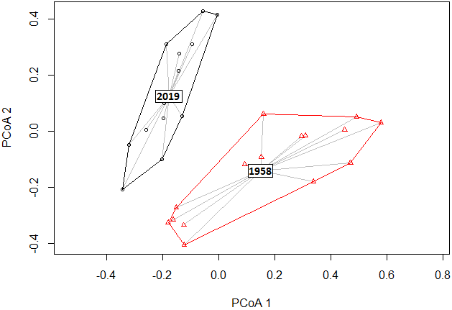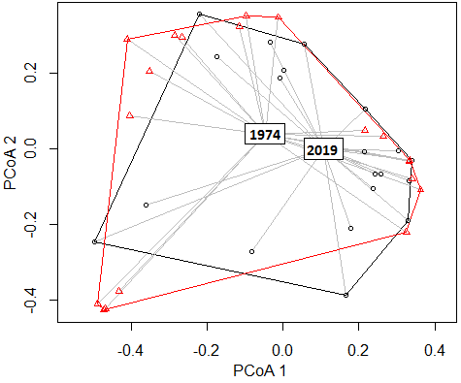
Visualization of species heterogeneity in (a) 1958 and (b) 1974 compared to 2019 (grey line) by principal coordinate analysis (PCoA). The connection lines between relevés and the median of a particular period group (rectangle with number of years) in the multidimensional space of Bray-Curtis dissimilarities between the images are shown. Polygons delimit the range of relevés of the particular year.

Supplementary figures regarding the overall trend of changes in species composition and plant functional groups among the studied periods 1950s, 1970s, and 2019.

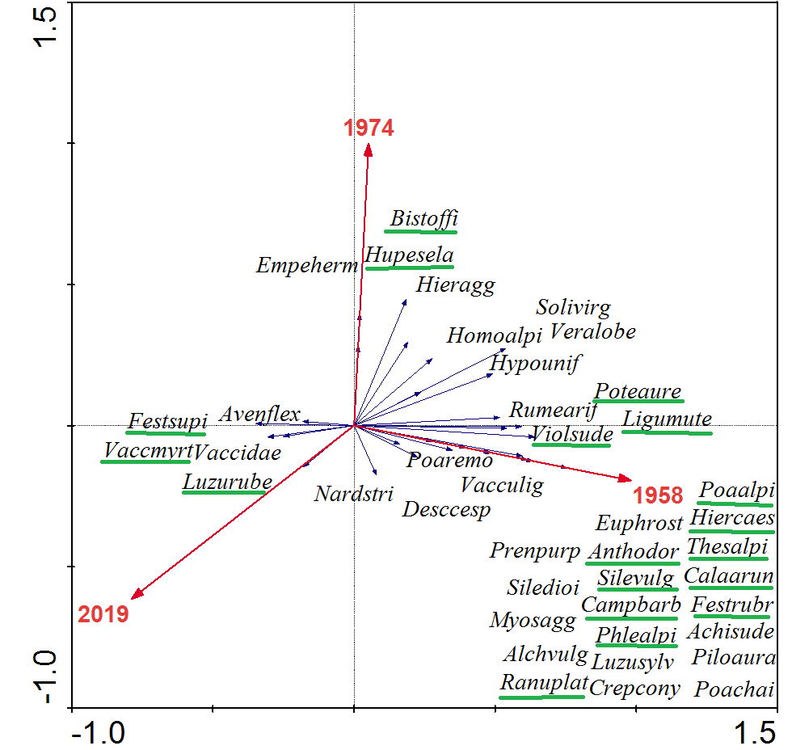
Restricted partial redundancy analysis (RDA) showing the association between the interaction of study years (1958, 1974, 2019) and vascular plant species composition. The first ordination axis explained 11% of the total variation, and the second axis explained 1.6% of the variability in species data after fitting alliances as covariates. Only the 41 species with weights greater than 3% are shown in the ordination diagram, and species with the largest weights (p < 0.05) are underlined.

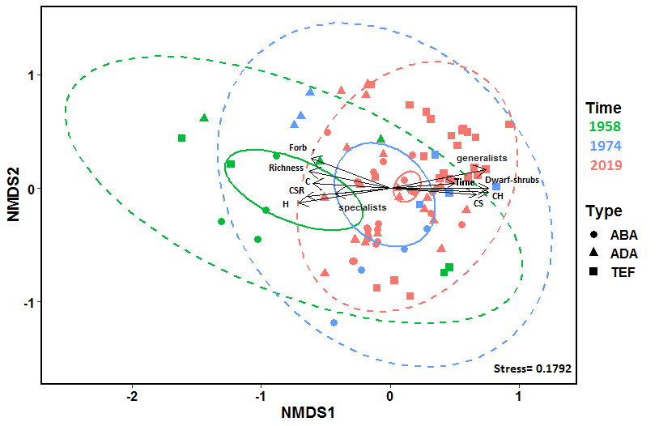
Diagram of nonmetric multidimensional scaling (NMDS) of a Bray-Curtis distance matrix describing the distribution of individual samples based on the variability of the plant functional groups in 1958 (green color), 1974 (blue color), and 2019 (red color). Points and ellipse colors indicate the period of time; dashed ellipses show changes in compositional heterogeneity and represent where 95% of the data lie, and solid ellipses show the overall shift in species composition and represent 95% confidence ellipses based on the standard errors of the average of the axis scores. The stress value is a measure of the disagreement between the rank order in the original dataset and that in the NMDS (lower numbers indicate better agreement). The stress value is a measure of the disagreement between the rank order in the original data set and that in the NMDS (lower numbers indicate better agreement). Arrows represent vectors of time shift (Time; r² = 0.24, p < 0.001), species richness (Richness: r² = 0.42, p < 0.001); cover of forbs (Forb; r² = 0.62, p < 0.001), dwarf shrubs (Dwarf shrubs; r² = 0.57, p = 0.001), CS-strategists (CS; r² = 0.44, p < 0.001), C-strategists (C; r² = 0.36, p < 0.001), CSR-strategists (CSR; r² = 0.42, p < 0.001); generalists (generalists; r² = 0.57, p < 0.001), specialists (specialists r² = 0.18, p < 0.001); hemicryptophytes (H; r² = 0.52, p < 0.001), chamaephytes (CH; r² = 0.58, p < 0.001). ABA – Cetario-festucetum supinae, ADA – Bistorto- Deschampsietum alpicolae, TEF – Festuco supinae- Vaccinietum myrtilli.

