Supplementary materials

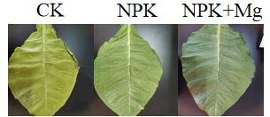
Figure S1 The color status of cigar tobacco leaves during harvesting.The tobacco leaves in the figure are the leaf state of CK, NPK and NPK+Mg fertilization treatment when they are ripe for harvest. The leaves of CK treatment are yellow, the leaves of NPK treatment are green, and the leaves of NPK+Mg treatment were dark green.
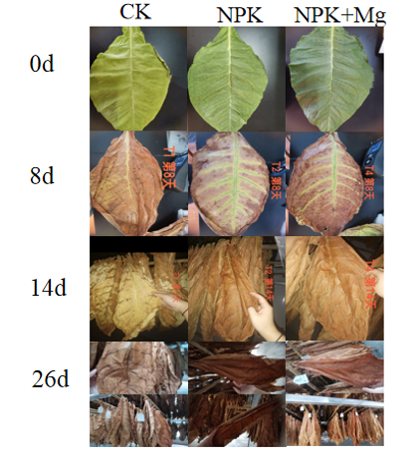
Figure S2 The color status of cigar tobacco leaves during airing.

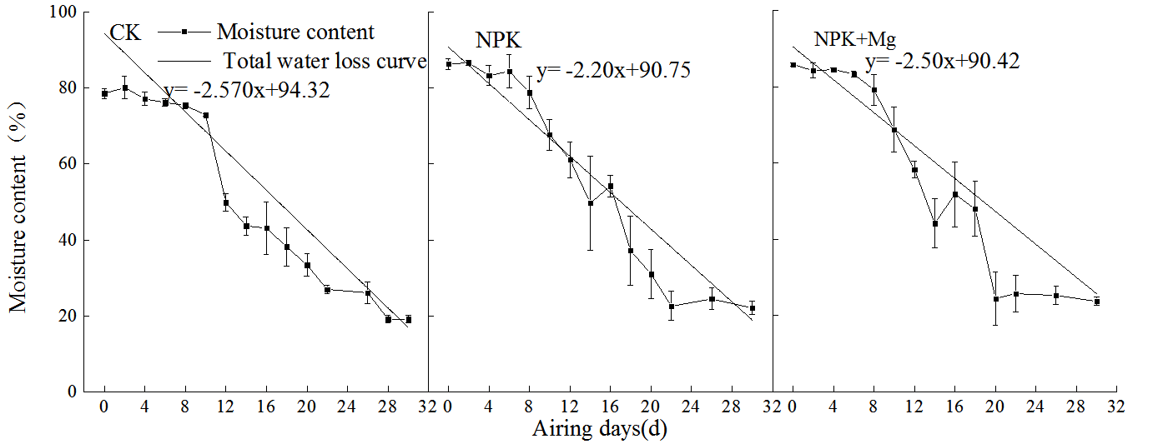

Figure S3 Changes of moisture content of cigar tobacco leaves during. The water loss rates of CK, NPK, and NPK+Mg treatments were 2.57, 2.2, and 2.50, respectively.

