Figure S1 Holotype Ranunculus dahlgreniae preserved in KRA.

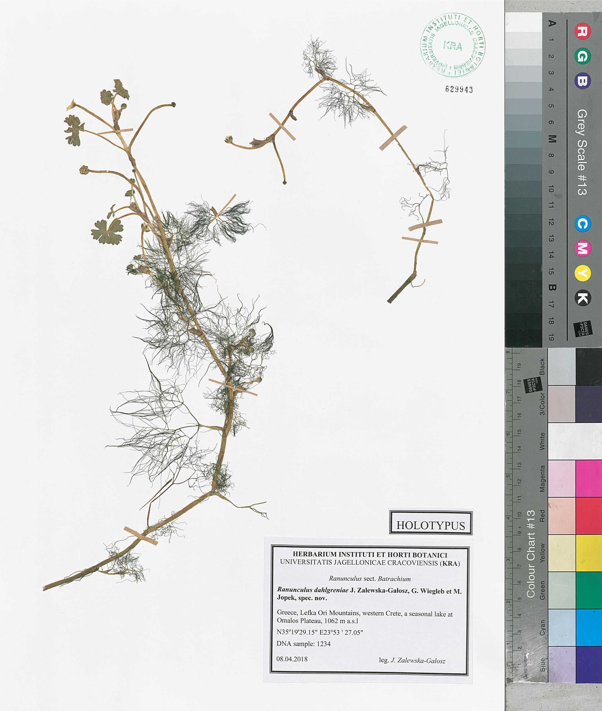

Figure S2 (A) Crete, Lefka Ori Mountains, a seasonal lake at Omalos Plateau, locus classicus of Ranunculus dahlgreniae sp. nov. (B) Flower and a floating leaf of Ranunculus dahlgreniae in the field. Photographs taken in April 2016 by Jenny Neal, reproduced with permission of the author.

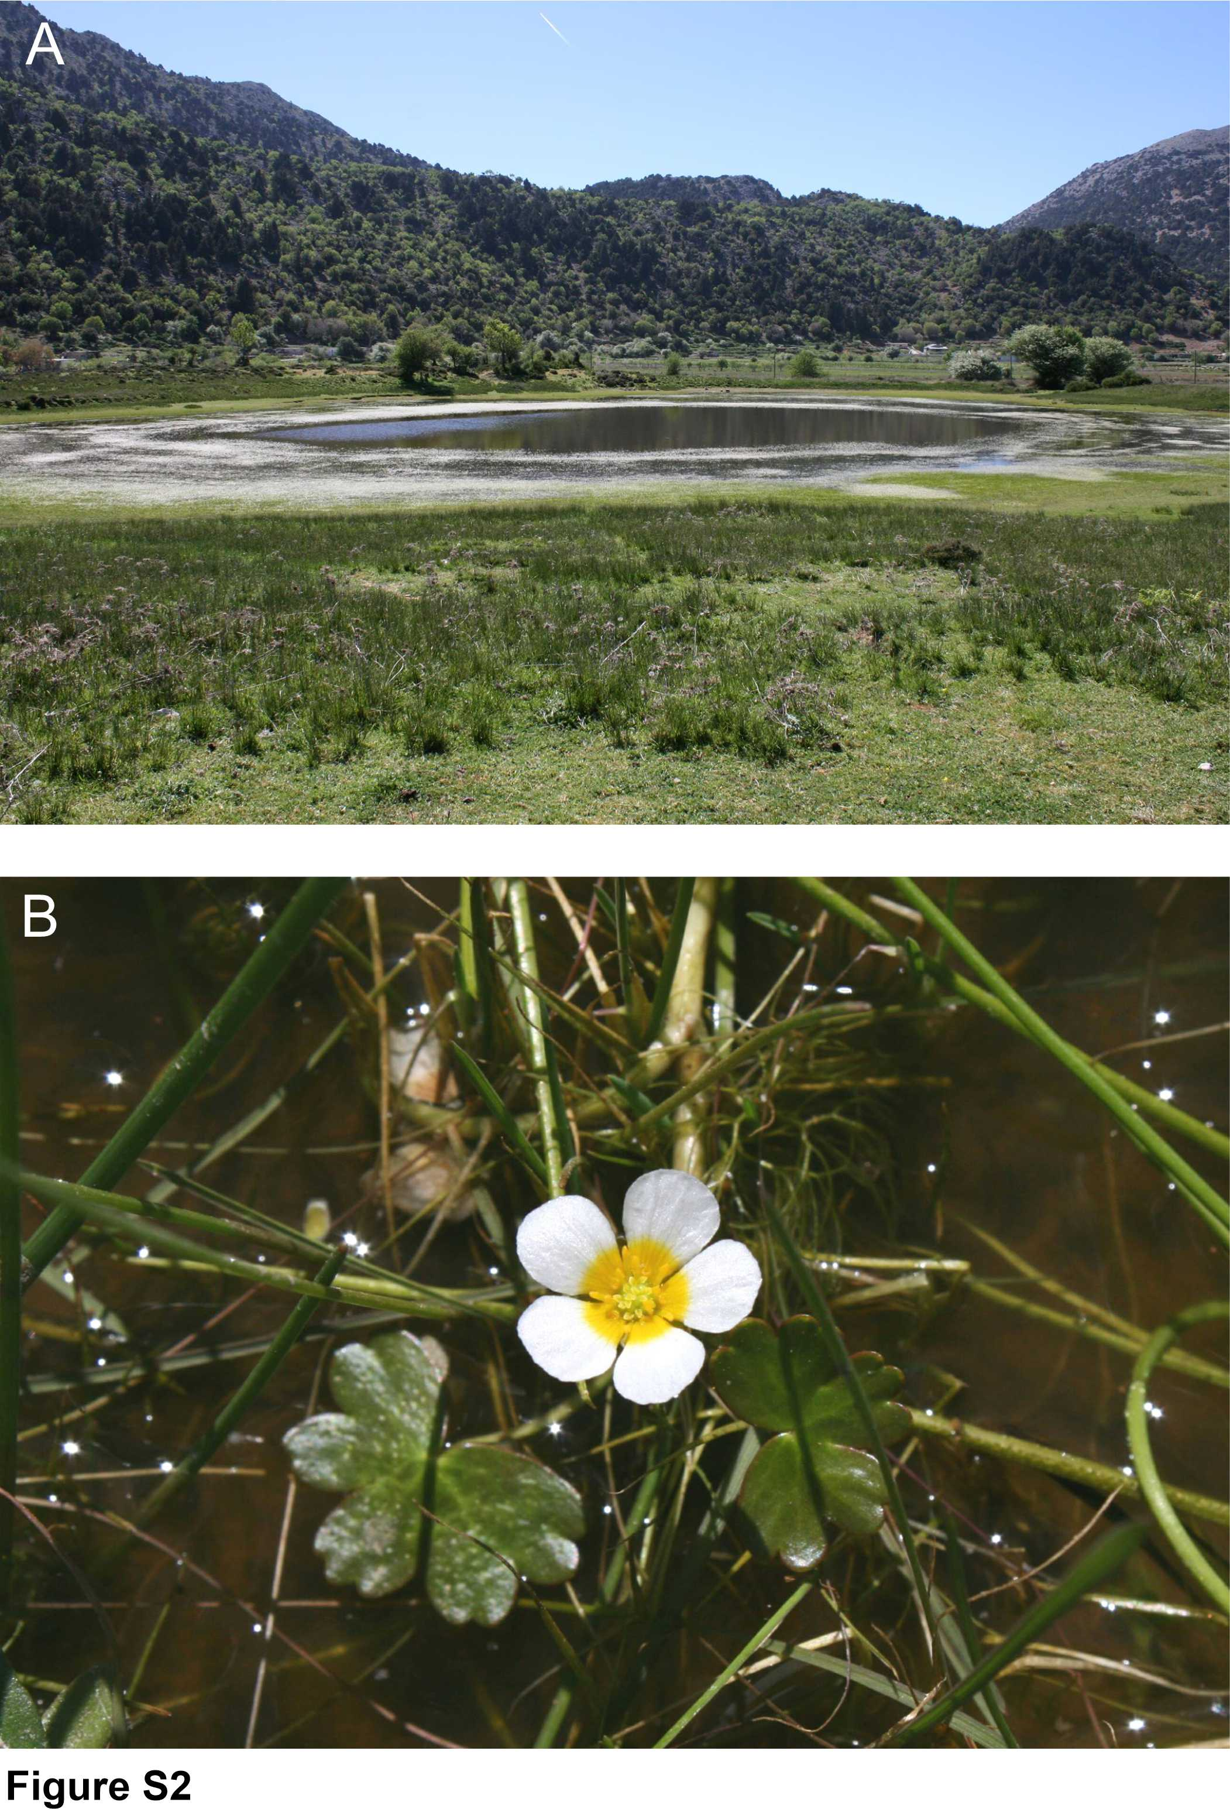

Figure S3 Ranunculus dahlgreniae in shalow parts of the lake. Photographs taken in April 2016 by Jenny Neal, reproduced with permission of the author.


