Appendix 1

New national and regional vascular plant records: Contribution to the flora of the Old World countries

Marcin Nobis^{1*}, Sławomir Wróbel², Ewelina Klichowska¹, Arkadiusz Nowak^{3,4}, Anna Wróbel^{1,5}, Agnieszka Nobis¹, Beata Paszko⁶, Sebastian Świerszcz^{3,7}, Wen-Li Chen⁸, †Paweł Kauzal², Marta Krzempek¹, Bing Liu⁸, Sylwia Nowak⁹, Renata Piwowarczyk¹⁰, Óscar Sánchez Pedraja¹¹, Antoni Zięba²

¹Institute of Botany, Faculty of Biology, Jagiellonian University, Gronostajowa 3, 30-387 Kraków, Poland
²Tatra National Park, Kuźnice 1, 34-500 Zakopane, Poland
³Polish Academy of Sciences Botanical Garden – Center for Biological Diversity Conservation in Powsin, Prawdziwka 2, 02-973 Warszawa, Poland
⁴Department of Botany and Nature Protection, University of Warmia and Mazury in Olsztyn, Łódzki Plac 1, 10-728, Olsztyn, Poland
⁵Doctoral School of Exact and Natural Sciences, Jagiellonian University, prof. S. Łojasiewicza 11, 30-348 Kraków, Poland
⁶Molecular Biogeography and Systematics Group, W. Szafer Institute of Botany, Polish Academy of Sciences, Lubicz 46, 31-512 Kraków, Poland
⁷The Franciszek Górski Institute of Plant Physiology, Polish Academy of Sciences; Niezapominajek 21, 30-239 Kraków, Poland
⁸ State Key Laboratory of Systematic and Evolutionary Botany, Institute of Botany, Chinese Academy of Sciences, CN-100093 Beijing, PR China
⁹Institute of Biology, University of Opole, Oleska 22, 45-052 Opole, Poland
¹⁰Center for Research and Conservation of Biodiversity, Institute of Biology, Jan Kochanowski University, Uniwersytecka 7, 25-406 Kielce, Poland
¹¹Grupo Botánico Cantábrico, E-39722 Liérganes (Cantabria), Spain

Achnatherum jacquemontii (Jaub. & Spach.) P.C. Kuo & S.L. Lu (Poaceae)
Contributors: Marcin Nobis, Ewelina Klichowska
Materials and Methods used for multivariate morphometric analyses
Morphological characters of vegetative and reproductive structures were examined in 56 individuals from the genus Achnatherum, including A. caragana (5 specimens from Tajikistan and Kyrgyzstan), A. saposhnikovia (3), A. turcomanicum (5), isotype of A. chuzomica (1 specimen from Bhutan), A. jacquemontii (38), A. sibiricum (4). Herbarium sheets with the examined Achnatherum specimens are deposited in KRA, LE, E, NY, BM, K (acronyms following Thiers (2022). Well-developed specimens were chosen and, measurements using digital calipers or a ruler were conducted. Each studied specimen of Achnatherum was treated as an Operational Taxonomic Unit (OTUs). The Pearson correlation coefficients or non-parametric Spearman correlation coefficients were calculated to check variables for strong correlation which could potentially affect the results of conducted analysis. If the correlation between the pair of variables exceeded r=0.90, one of them were excluded. A total of 10 most informative quantitative and qualitative morphological characters were chosen for analysis, including 8 quantitative characters, named as follows: Length of the anthecium (mm), Length of the awn (mm), Length of the callus (mm), Length of hairs in the dorsal line on the lemma (mm), Length of the hairs in the lower part of awn (mm), Length of the lower glume (mm), The length of the stem (cm), Number of awn bends, as well as 2 qualitative: Character of awn (1—impermanent, 2—permanent); Panicle type (1—loose; 2—compact). To obtain information about general relationships between studied representatives of genus Achnatherum, Cluster analysis (UPGMA method) was performed based on Gower’s general similarity coefficient.

Table S1 The list of species cooccurring with A. jacquemontii in sample plots (relevés) based on Braun-Blanquet cover-abundance scale; 5 = cover >75%, 4 = cover 50-75%, 3 = cover 25-50%, 2 = cover 5-25%, 1 = cover <5%, + = few individuals with <1% cover, r = solitary individuals.

Achnatherum sibiricum (L.) Keng ex Tzvelev (Poaceae)
Conributors: Marcin Nobis, Agnieszka Nobis
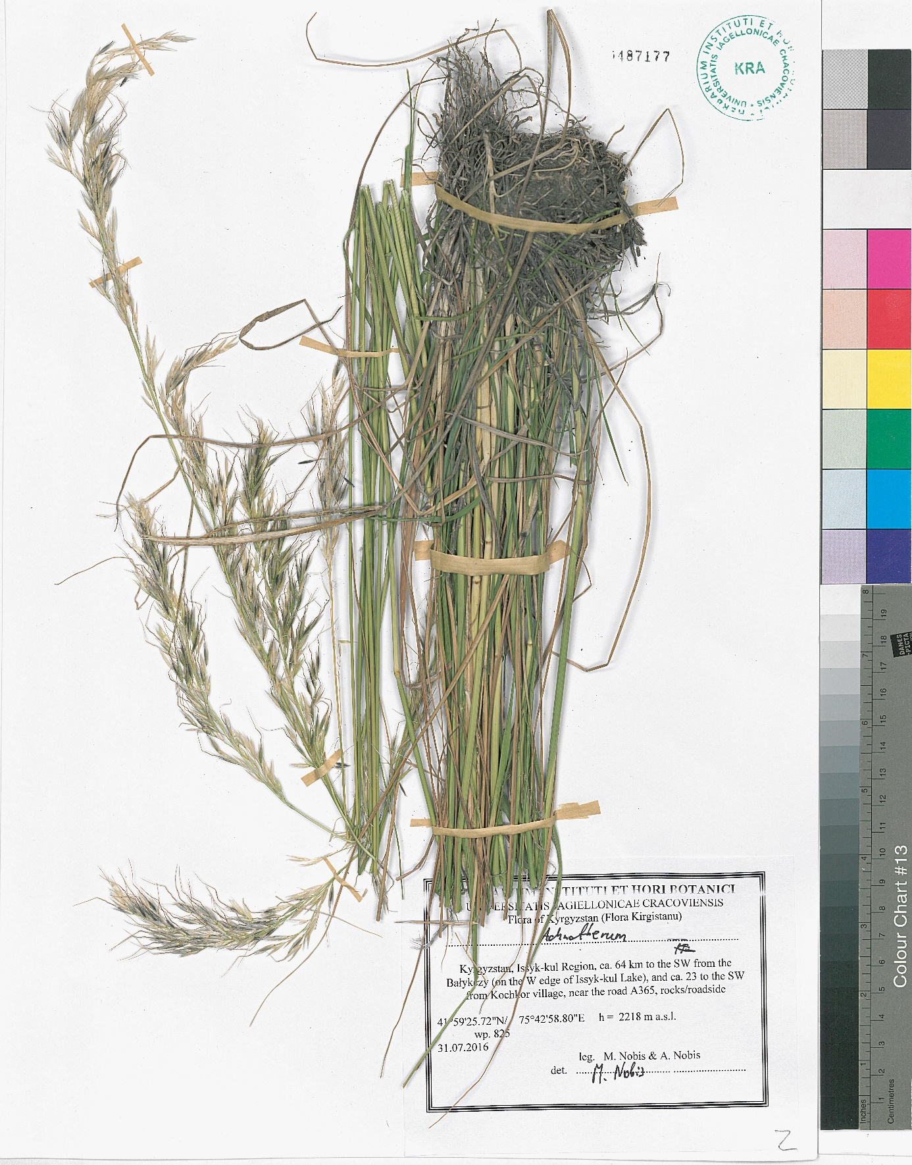
Figure S1 Herbarium specimen of Achnatherum sibiricum (L.) Keng ex Tzvelev from a new locality in Kyrgyzstan.

Arrhenatherum elatius (L.) P. Beauv. ex J. Presl & C. Presl (Poaceae)
Contributors: Marta Krzempek, Marcin Nobis
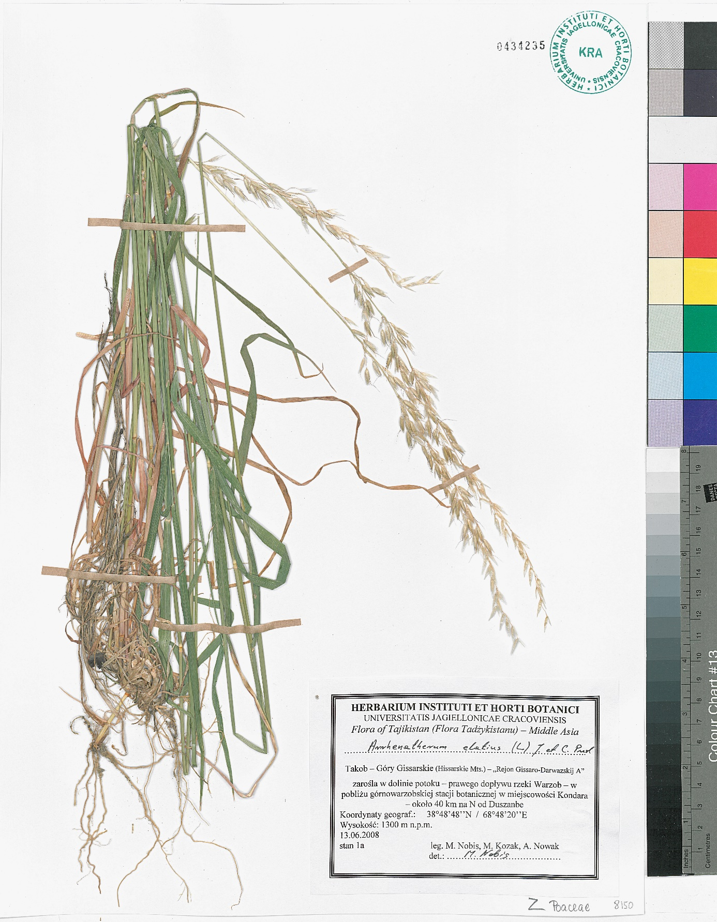
Figure S2 Herbarium specimen of Arrhenatherum elatius from a new locality in Tajikistan.

Asyneuma thomsonii (Hook.f.) Bornm. (Campanulaceae)
Contributors: Marcin Nobis, Ewelina Klichowska

Materials and methods used for molecular investigations

Dried leaf tissues were powdered by using a mixer mill (MM400 Retsch) with 3-5 mm glass beads, next genomic DNA was extracted by using the Genomic Mini AX Plant kit (A&A Biotechnology, Poland). The concentration, as well as purity of DNA extraction products, were checked by 1% agarose gel electrophoresis and spectrophotometrically using a NanoDrop ND-1000 (Thermo Fisher Scientific, USA). To meet the assumptions of DArTseq genotyping procedure, the samples were diluted to the concentration of 70 ng/μL, whereas for PCR (ITS and cpDNA) purposes up to 10 ng/μL.
The nuclear ribosomal Internal Transcribed Spacer region (including ITS1, 5.8S, and ITS2) as well as three cpDNA regions (petD, trnK-psbA, rpl16) were amplified using the primers and PCR conditions described previously (Nobis et al., 2023; Vintsek et al., 2023). In both cases, agarose gel electrophoresis was used to detect the presence or absence of the target sequence and the length of the fragment. The PCR products were purified using the Exo-BAP Kit (EURx, Poland) and sequenced by an external company (Genomed, Poland) by using paired-end Sanger sequencing. After that, the sequences were manually verified and aligned using BioEdit ver. 7.0.5.3 (T. Hall, 1999). The studied samples of Asyneuma japonicum came from old herbarium collections, and therefore they could not be amplified. For this reason, the sequences of A. japonicum with accession numbers: MK555695.1, MK555921.1, MK556372.1, MK556661.1 (Xu & Hong, 2021) were downloaded from GenBank (Clark et al., 2016). After aligning in BioEdit ver. 7.0.5.3 (T. A. Hall, 1999) along with our sequences, were used to create the phylogenetic tree. The phylogenetic tree based on the concatenated alignment of 2128 bp (ITS and cpDNA) were constructed. We used Bayesian Inference (BI) conducted in MrBayes 3.2.6 (Ronquist et al., 2011), with MCMC simulation set for 4,000,000 generations sampled every 1000 generations, and 25% of iterations discarded as a burn-in fraction. The results of the Bayesian analysis were placed into a visual form using FigTree v. 1.4.0 software (A. Rambaut, 2018).
Genome complexity reduction using restriction enzymes and high-throughput polymorphism detection (Kilian et al., 2012) was performed by Diversity Arrays Technology Pty Ltd (Canberra, Australia). Several enzyme combinations for complexity reduction were tested and the PstI-MseI method for Campanula was selected. Library preparation and sequencing were performed according to the previously reported procedures (Baiakhmetov et al., 2020). Phylogenetical analyses were performed using co-dominant single nucleotide polymorphisms (SNPs) markers in R v. 4.0.3 (R Core Team, 2020) with the package dartR v.2.3.3 (Gruber et al., 2021). All monomorphic loci were removed, loci identified (= called) in greater than 70%, as well as loci with a scoring reproducibility of 100% were kept, secondary loci were filtered to keep only one random sequence tag, and at the end, loci were filtered based on the minor allele frequency (MAF) threshold of 1%. Neighbor Joining (NJ) method were used to construct phylogenetic tree based on the Euclidean distance by using dartR package v.2.3.3 (Gruber et al., 2021). The NJ phylogenetical tree was visualized using FigTree v. 1.4.4 (Rambaut, 2018). The analysis was performed based on 459 SNPs derived from 10 individuals from the Campanulace.
The SNP dataset derived from the DArTseq pipeline in the genlight format as well as concatenated alignment from ITS and cpDNA in the fasta format are available via Figshare repository, https://figshare.com/s/c060a6ef5eba1b2e5298.

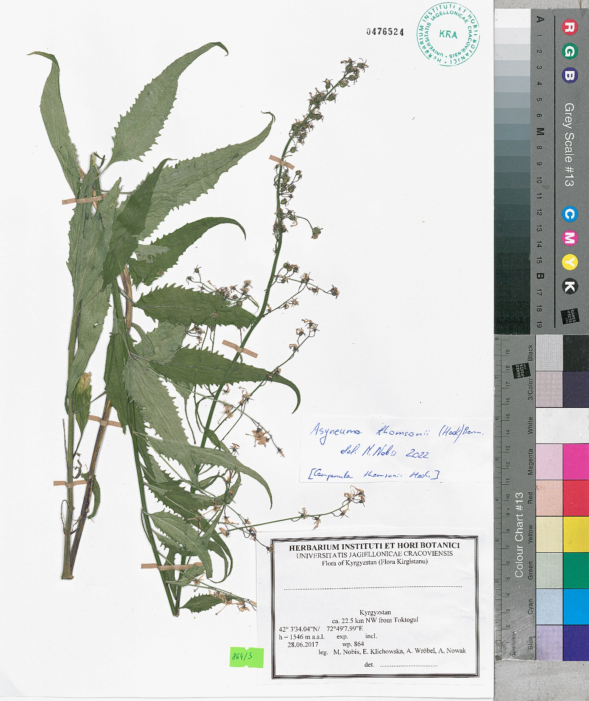
Figure S3 Herbarium specimen of Asyneuma thomsonii from a new locality in Talas region (Kyrgyzstan).

Calamagrostis emodensis Griseb. (Poaceae)

Contributors: Beata Paszko & Wen-Li Chen

Other examined specimens of Calamagrostis emodensis Griseb.:
Bhutan. Gasa: Upper Mo Chu District, on way to Laya, wet and rocky ground, [27.975°N, 89.754°E], 17 Aug. 1995, R. Pradhan LG189 (E!). Chukka: above Gedu, on road to microwave station, [26.95°N, 89.5°E], landslip in oak forest, 26 Sept. 1998, Noltie et al. 330 (E!).
CHINA. Chongqing: Nanchuan Distr., Jinshan, Fenghuang, [29.248°N, 106.969°E], 2050 m., J.H. Xiong & Z.L. Zhou 92591 (KUN, PE). Shaanxi: Yang Co.,Long Shan, Huayang, mountain peak, 1900 m., [33.592°N, 107.537°E], 29 July 1952, B.Z. Guo (B.C.Guo) (PE). Sichuan: Lixian, Qionglai Shan, Shou Lougou, tributary valley of Somang Qu (Rv.).ca. 40 km W of Weizhou, Mt. valley, lower slopes and bottom, 1970 m, 31.167°N, 103.083°E, 17 September 1997, R. J. Soreng et al. 5350 (KUN, PE, US); Meigu, Houbritou distr., 23 August 1959, J.L. Chuan 1951 (KUN, PE); Guanxian Co. [current name Dujiangyan], Longxi, ravine, 1850 m., [31.275°N, 103.689°E], 18 August 1988, D.Z. Fu 87-1340 (PE); Ebian Co., Jifengwenba, mountain slope, 2620 m., 22 August 1959, Z. T. Guan 6603 (PE); Mt. Omei (Emeishan), Omei-hsien, at grassy slope, 1676.4‒1828.8 m., [29.513°N, 103.312°E], 17 August 1928, W.P. Fang 3084 & 2807 (PE); Jinchuan Co., Wanlin, Lijiangou, grassy slope along stream, 2600 m., [31.464°N, 102.113°E], 26 July 1958, X. Li 78217 (PE); Jinchuan Co., Honghualewu, mountain slope, 2200 m., 31 July 1959, Sichuan Economic Plants Investigation Team 1524 (PE); Luding Co., E slope of Gongga Shan, Hailuogou National Park, forest, 2680‒2900 m., 29.333°N, 102°E, 7 October 1997, R. J. Soreng et al. 5698 (PE, KUN, US); Tianquan Co., Kunniuping, Maliuqiao, Erlangshan Mt., roadside of mountain slope, 2450 m., [29.967°N, 102.333°E], 27 August 1963, K.J. Guan & W. T. Wang 2034 (PE); Wenchuan Co., Wolong protected area, along stream, 2400 m., [31.02°N, 103.1°E], 27 August 1982, K. Y. Lang et al., 1290 (PE); Xiaojin Co., Congshenggou, mountain slope, 2500 m., [30.755°N, 102.123°E], 20 August 1958, X.B. Zhang & Y. X. Ren 6727 (PE). Xizang: Bomi Co., close to the county town, mountain grassy slope, 2900 m., 29.867°N, 95.755°E, 26 August 1980, Z. C. Ni et al. 1373 (PE); Cuona Co., Lebuqu, mountain grassy slope, 2800 m., [27.804°N, 91.704°E], 5 October 1974, Qinghai-Xizang Exped. 74-2804 (KUN, PE); [Nyalam Co.], Niemula Co, midway from Zhangmu to friendship bridge, roadside, 2000 m., [27.976°N, 85.975°E], 19 August 1972, Xizang medicinal plants investigation Team 1367 (PE); [Nyalam Co.], Niemula Co, Quxiang, mountain slope, 3200 m., [28.074°N, 86°E], 9 September 1982, Xizang medicinal plants investigation Team 1583 (PE); Motuo Co., Galongla Shan, roadside, 2500 m., [29.756°N, 95.702°E], 15 August 1982, S. Z. Chen & B. S. Li 00087 (PE); Yadong Co., Kangbugou, 3500 m., mountain grassy slope, [27.686°N, 88.964°E], 25 September 1981, Z. C. Ni et al.2437 (PE); Zayü (Chayu) Co., Ridong distr., 3200 m., [28.435°N, 98.431°E], 9 September 1982, Qinghai-Xizang Exped. 10300 (KUN, PE). Yunnan: Dali Co., W of Er hai Lake, Diancang Shan (Cangshan), E slope, side of the mountain track, 2395 m., 25.706°N, 100.123°E, 24 August 2010, B. Paszko GPS 634 (KRAM); Deqin Co., Tehching, Muyung, ravine, 2500 m., [28.486°N, 98.911°E], 29 September 1937, T.T. Yu (PE); Fugong Co., W slope of Biluo Mts., steep upper mountain slope, with thickets, 2900‒3200 m., 26.5°N, 100°E, 8 September 1997, R. J. Soreng et al. 5230 (KUN, PE, US); Fugong Co., W slope of Bilou Mts., E side of Nu Jiang (Salween Rv.), above Bijiang ca. 9 km by road, in 2nd growth forest of Alnus nepalensis, Quercus, Lithocarpus, Tsuga, Betula, with Fargesia, Hydrangia, Buddleja, Shefflera, 2590 m., 26.5°N, 99.983°E, 3 September 1997, R. J. Soreng et al. 5252 (KUN, US); Gongshan Co., Shezhi Ju, Qiujiang [formerly Dulong], mountain slope, 2000 m., 27.738°N, 98.349°E, 1 October 1935, C. W. Wang 67147 (PE, KUN); Gongshan Co., Shezhi Ju, Suroula (Su-roo-la), mountain slope, 3000 m., 27.748°N, 98.662°E, 1 September 1935, C. W. Wang 66701 (PE, KUN); Longyang Distr., Shweli-Salwin divide, rocky pasture, 25.335°N, 98.815°E, August 1912, G. Forrest 8898 (PE); Lushui Co., Gaoligongshan West slope, old clearing and edges of thickets and roadside, 2880 m., 26°N, 98.65°E, 9 September 1997, R. J. Soreng et al. 5270 (KUN, PE, US); Pianma, roadside, 2750 m., 26.013°N, 98.618°E, 30 September 2002, H.Y. Ma 133 (KUN).
India. Sikkim: [without precise locality], 1828.8‒2743.2 m, temp., s.d., J. D. Hooker s.n. (GOET!, M!); Lachoong, 3352.8‒3657.6 m, [27.687°N, 88.752°E], 30 Aug. 1849, J. D. Hooker s.n. (K!). Jammu & Kashmir (disputed area): Anantnag distr., above Pahlgam [Pahalgam], 2590 m, [34.0397°N, 75.328°E], 3 Aug. 1956, O. Polunin 56/469 (BM!); Kashmir, Sept. 1874, Atkinson 24180A (BM!). Himachal Pradesh: Lahul and Spiti, Keerting, Shansha, along stream with roots in water, 2740 m, [32.614°N, 76.905°E], 26 Aug. 1930, W. Koelz 1231 (MICH!). Uttarakhand: Tehri state, Chitoni, among rocks, 3660 m, 29 Sept. 1948, T. Rup Chand 1247 (MICH!).
MYANMAR. Kachin: NE Upper Burma, hills around Atawgaw, [26.167°N, 98.417°E], 1829–2134 m, Sept. 1924, G. Forrest 24995 (E!); NE Upper Burma, 1829–2134 m, Sept. 1924, G. Forrest 24995 (K!).
Nepal. Bagmati Zone: [Rasuwa distr.], Langtang village, 3505.2 m, [28.216°N, 85.508°E], 1 Aug. 1949, Polunin 1522 (BM!); [Rasuwa distr.], Tukucha, Kali Gandaki, 3048 m, [28.922°N, 83.824°E], 24 Sept. 1954, Stainton et al. 7994 (BM !). Dhawalagiri Zone: above Dogadi Khola, sheltered scree, 4114.8 m, [28.71°N, 83.013°E], 28 Sept. 1954, Stainton et al. 4629 (BM!, E!, K!). Gandaki Zone: Kaski Distr., Banthati (2600 m) – Deurali (3050 m) – Ghodepani Deurali (Ghorapani) (2830 m), on sunny moist roadside, 2700 m, [28.387°N, 83.746°E], 24 Aug. 1988, M. Suzuki et al. 8881300 (BM!). Janakpur Zone: Dolkha distr. Rolwaling Khola, 3000 m, [27.905°N, 86.354°E], 22 Oct. 1981, M. A. Farille 81-753 & M. A. Farille 81-755 (E!). Karnali Zone: Rohagaon, Suli Gad, growing on the bank of stream, 2896 m, [29.003°N, 82.922°E], 13 Sept. 1952, O. Polunin et al. 3370 (BM!, E!). Koshi Zone: between Tudam and Chyantang, growing on rock faces near a water fall, 3200 m, [27.822°N, 87.414°E], 12 Nov. 1971, L. W. Beer 10731 (BM!); between Tudam and Ritak, on a rocky river bank, [27.748°N, 87.507°E], 13 Nov. 1971, L.W. Beer 12217 (BM!); Bhararate Himal: Barun valley, on moraine scree below the Yangle pasture, 3500 m, [27.746°N, 87.173°E], 4 Oct. 1972, T. Wraber 34701, Pl. Nepalenses 1972 No. 394 (BM!). Mechi Zone: Baroya Khimty-Thakma Khola, [27.512°N, 87.829°E], 16 Nov. 1963, H. Kanai et al. 6302134 (BM!); Tamur Valley, Yangma Khola, NE of Walungchung Gola, in Abies forest, 3660 m, [27.698°N, 87.829°E], J. D. A. Stainton 1094 (BM!, E!); Topke Gola, growing on an exposed rock face, 3200 m, [27.64°N, 87.583°E], 25 Oct. 1971, L. W. Beer 10640 (BM!); Tamur River, Nov. 1955 – Jan. 1956, M. Brough 31 (BM!); Yangma valley, riverside among stones, Nov. 1955 – Jan 1956, M. Brough 18 (BM!). Sagarmatha Zone: Solu Khumbu: Jorsale, along trail to Namche Bazar, N of Jorsale, 2820 m, 27.783°N, 86.723°N, 12 Sept. 2005, Third Darwin Nepal Fieldwork Training Expedition DNEP3 AX25 (E!). Nipal orient., s.d., J. D. Hooker s.n. (K!).

Calamagrostis obtusata Trin. (Poaceae)
Synonyms: Calamagrostis agrostioides Matuszk.
Contributors: Beata Paszko & Bing Liu
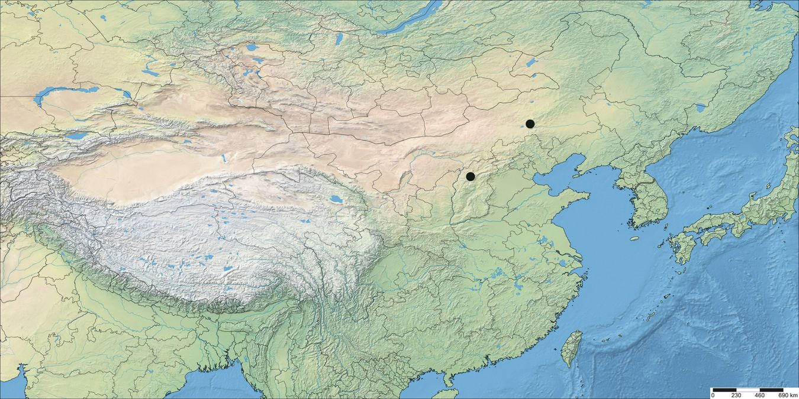
Figure S4 Distribution map for Calamagrostis obtusata in China produced using SimpleMappr (http://www.simplemappr.net/).

Gentiana orbicularis Schur (Gentianaceae)
Contributors: Sławomir Wróbel, Anna Wróbel

Materials and methods used for molecular investigations
Leaf tissue of Gentiana individuals was preserved in silica gel after collection in the field. DNA from dried leaves was isolated using a Genomic Mini AX Plant Spin kit (A&A Biotechnology, Poland) in accordance with the manufacturer′s protocol. The marker ITS1-5.8 S-ITS2 of nuclear ribosomal DNA was amplified as a whole using forward primer ITS5: 5′-GGAAGTAAAAGTCGTAACAAGG-3′ and reverse primer ITS4: 5′-TCCTCCGCTTATTGATATGC-3′ (White et al., 1990). Amplification reactions were performed in a total volume of 25µl, containing: 2.5 μl of 10× DreamTaq Green Buffer (Thermo Scientific, USA), 0.3 μl of 10 mM dNTPs MIX (A&A Biotechnology, Poland), 0.3 μl of 5 U/μl DreamTaq Green DNA Polymerase (Thermo Scientific, USA), 0.5 μl of each primer (10 pmol/µl), 0.1 µl of BSA (20 mg/ml; Thermo Scientific, USA) and 1 μl of a template DNA (10 ng/µl). Ultrapure H₂O was added to obtain a total volume of 25 μl. The PCR mixes were heated at 94°C for 3 min prior to 25 cycles of PCR amplification performed in a T100 Thermal Cycler (Bio-Rad, USA). Each cycle included – denaturation for 1 min at 94 °C, annealing for 2 min at 50–56 °C, and elongation for 2 min at 72 °C. Following the last cycle, the PCR mixes were incubated at 72°C for 7 min. PCR matrices were sent to an external company (Genomed, Poland) for paired-end Sanger sequencing. The resulting sequences were manually verified and aligned using BioEdit ver. 7.0.5.3 (T. A. Hall, 1999). One sequence of Gentiana orbicularis, accession number: KT907682.1 (Favre et al., 2016), one of Gentiana verna, accession number KT907736.1 (Favre et al., 2016), and one of Gentiana brachyphylla, accession number: KF563949.1 (Favre et al., 2016) were taken from the GenBank repository and added to the ITS1-5.8 S-ITS2 dataset (Table S2) as references to compare their DNA profiles with our samples. One sequence of Gentiana asclepiadea, accession number: GU251025.1 (Favre et al., 2010) was used as an outgroup. The sequences were analysed using the Maximum Likelihood method in MEGA software (Kumar et al., 2016) using 1000 bootstrap replicates and General Time Reversible model ] (Nei & Kumar, 2000).

Table S2 GenBank accessions of ITS1-5.8 S-ITS2 of nuclear ribosomal DNA generated in this study for Gentiana species from the Tatra Mountains, Poland.
Accession | Isolate | Species | Locality | Collection date
OP743368 | GEN16 | Gentiana orbicularis | Poland: Tatra Mountains, Liliowe Turnie | 14-06-2022
OP743369 | GEN18 | Gentiana orbicularis | Poland: Tatra Mountains, Liliowe Turnie | 14-06-2022
OP743370 | GEN21 | Gentiana orbicularis | Poland: Tatra Mountains, Starorobociański Wierch | 20-06-2022
OP743371 | GEN23 | Gentiana orbicularis | Poland: Tatra Mountains, Starorobociański Wierch | 20-06-2022
OP743372 | GEN1 | Gentiana verna | Poland: Tatra Mountains, Kopieniec | 05-05-2021
OP743373 | GEN7 | Gentiana verna | Poland: Tatra Mountains, Rusinowa Polana | 13-05-2021
OP743374 | GEN12 | Gentiana verna | Poland: Tatra Mountains, Kominiarski Wierch | 13-07-2021

Orobanche bartlingii Griseb. (Orobanchaceae)
Contributors – Renata Piwowarczyk & Óscar Sánchez Pedraja
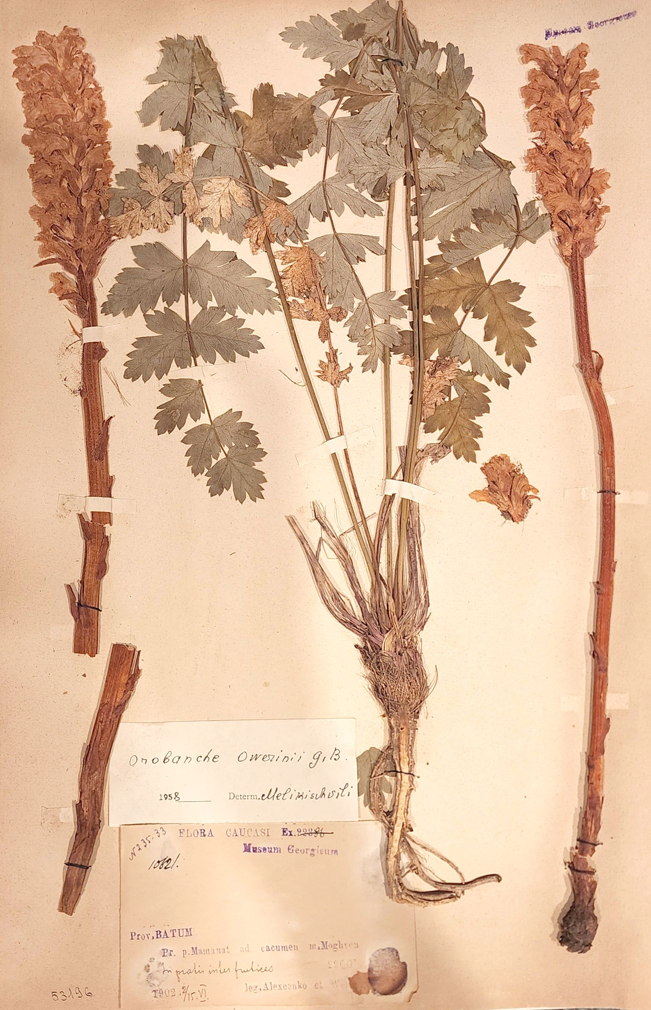
Figure S5 Herbarium specimen of Orobanche bartlingii Griseb. from a new locality in Borçka district of Artvin Province (Turkey).
Stipa × balkanabatica M. Nobis & P.D. Gudkova
Contributors – Marcin Nobis & Ewelina Klichowska

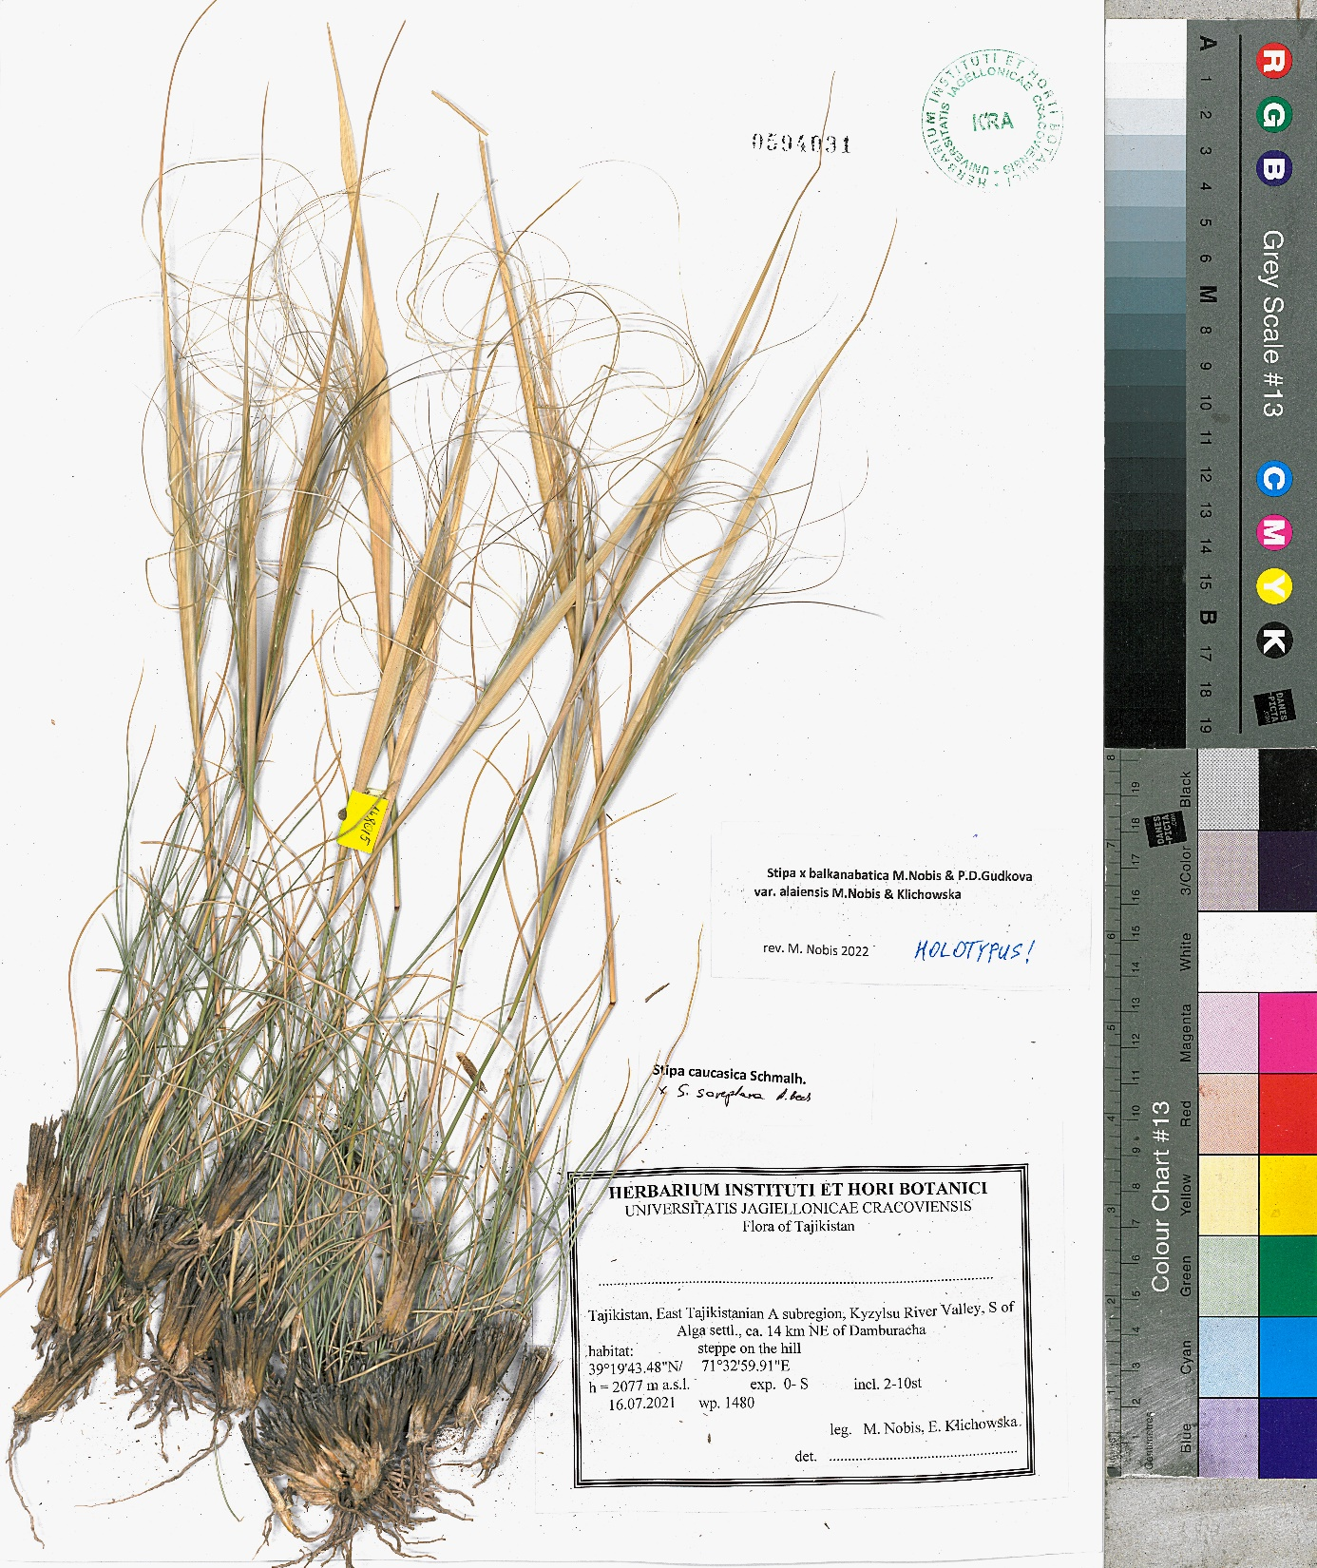
Figure S6 Holotype of Stipa × balkanabatica var. alaiaensis M. Nobis & Klichowska from a locality in Kyzylsu River Valley (Tajikistan).

References
Baiakhmetov, E., Nowak, A., Gudkova, P. D., & Nobis, M. (2020). Morphological and genome-wide evidence for natural hybridisation within the genus Stipa (Poaceae). Scientific Reports, 10(1), 1–14. https://doi.org/10.1038/s41598-020-70582-1
Clark, K., Karsch-Mizrachi, I., Lipman, D. J., Ostell, J., & Sayers, E. W. (2016). GenBank. Nucleic Acids Research, 44(Database issue), D67. https://doi.org/10.1093/NAR/GKV1276
Favre, A., Michalak, I., Chen, C., Wang, J., Pringle, J. S., Matuszak, S., Sun, H., Yuan, Y., Struwe, L., & Muellner‐Riehl, A. N. (2016). Out‐of‐Tibet: the spatio‐temporal evolution of Gentiana (Gentianaceae). Journal of Biogeography, 43(10), 1967–1978. https://doi.org/10.1111/jbi.12840
Favre, A., Yuan, Y.-M., Küpfer, P., & Alvarez, N. (2010). Phylogeny of subtribe Gentianinae (Gentianaceae): Biogeographicinferences despite limitations in temporal calibration points. Taxon, 59(6), 1701–1711.
Gruber, B., Unmack, P., Berry, O., & Georges, A. (2021). Introduction to dartR.
Hall, T. (1999). Bioedit: a user-friendly biological sequence alignment editor and analysis program for windows 95/98/ nt. https://doi.org/10.14601/PHYTOPATHOL_MEDITERR-14998U1.29
Hall, T. A. (1999). BioEdit: a user-friendly biological sequence alignment editor and analysis program for Windows 95/98/NT. Nucleic Acid Symposium Series, 41, 95–98.
Kilian, A., Wenzl, P., Huttner, E., Carling, J., Xia, L., Blois, H., Caig, V., Heller-Uszynska, K., Jaccoud, D., Hopper, C., Aschenbrenner-Kilian, M., Evers, M., Peng, K., Cayla, C., Hok, P., & Uszynski, G. (2012). Diversity Arrays Technology: A Generic Genome Profiling Technology on Open Platforms. Methods in Molecular Biology, 888, 67–89. https://doi.org/10.1007/978-1-61779-870-2
Kumar, S., Stecher, G., & Tamura, K. (2016). MEGA7: Molecular Evolutionary Genetics Analysis Version 7.0 for Bigger Datasets. Molecular Biology and Evolution, 33(7), 1870–1874. https://doi.org/10.1093/MOLBEV/MSW054
Nei, M., & Kumar, S. (2000). Molecular Evolution and Phylogenetics. Oxford University Press.
Nobis, M., Klichowska, E., Vintsek, L., Wróbel, A., Nobis, A., Zalewska-Gałosz, J., & Nowak, A. (2023). Evolutionary response of cold-adapted chasmophytic plants to Quaternary climate oscillations in the Mountains of Central Asia (a world hotspot of biodiversity). Diversity and Distributions.
R Core Team. (2020). R: A language and environment for statistical computing (4.0.3). R Foundation for Statistical Computing. https://www.r-project.org/
Rambaut, A. (2018). Figtree v1.4.4. http://tree.bio.ed.ac.uk/software/figtree/
Thiers, B. (2022). Index Herbariorum: A global directory of public herbaria and associated staff. New York Botanical Garden’s Virtual Herbarium. http://sweetgum.nybg.org/ science/ih/
Vintsek, L., Klichowska, E., Nowak, A., & Nobis, M. (2023). Insight into phylogeny and evolutionary history of the genus Sergia (Campanulaceae) and its response to the climate changes predicted for the Mountains of Central Asia (a world biodiversity hotspot). Scientific Reports.
White, T. J., Bruns, T., Lee, S. B., & Taylor, J. W. (1990). Amplification and direct sequencing of fungal ribosomal RNA genes for phylogenetics. In PCR Protocols (pp. 315–322). Academic Press.
Xu, C., & Hong, D. Y. (2021). Phylogenetic analyses confirm polyphyly of the genus Campanula (Campanulaceae s. str.), leading to a proposal for generic reappraisal. Journal of Systematics and Evolution, 59(3), 475–489. https://doi.org/10.1111/JSE.12586/SUPPINFO

