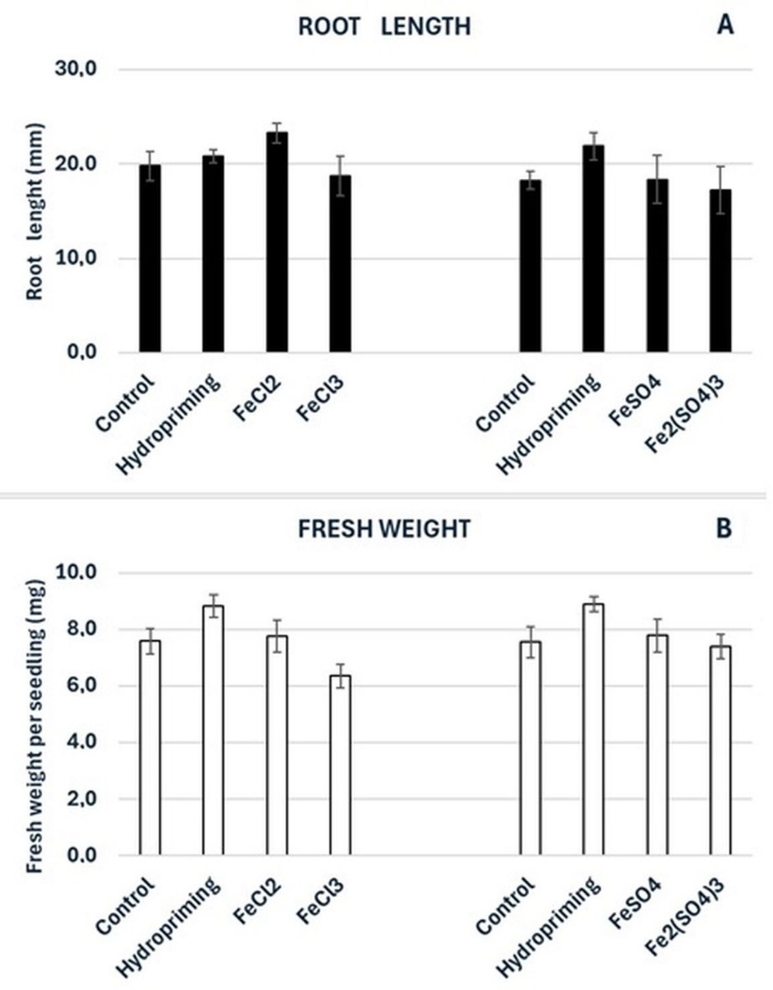

Figure S1 Root length (A) and fresh weight (B) of broccoli seedlings grown from the control and hydroprimed seeds and from the seeds imbibed in Fe solutions at the Fe concentration of 500 mg·dm⁻³.The results are means of four independent experiments (n=4) ±SE.

