Supplementary material
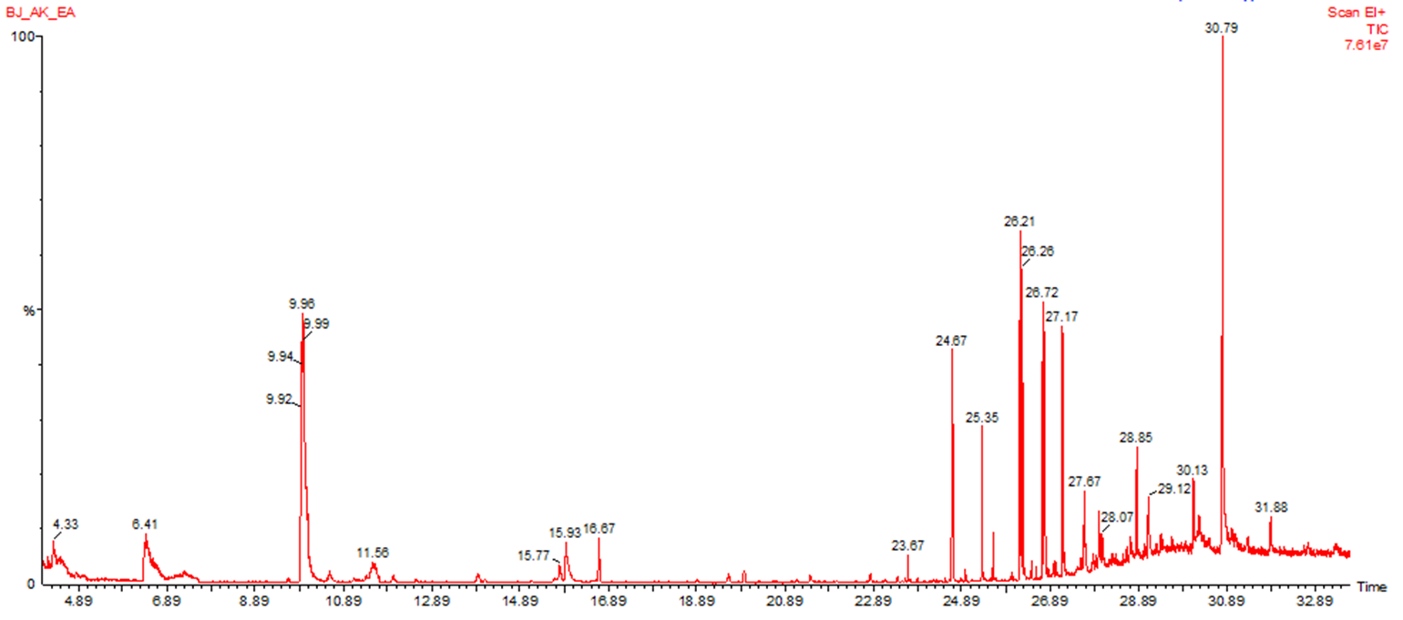
Figure S1 GC/MS chromatogram of non-polar fraction of A. palaestinum spadices (EtOAc extract).

Table S1 % inhibition of HeLa cancer cell lines using different concentrations of the extracts.
Extract | % Inhibition
Extract | Concentration (µg/mL)
Extract | 250 | 500 | 2,000 | 4,000
Flavonoids | 0.0 | 1.0 | 23.9 | 39.9
Spadices | 0.0 | 0.0 | 1.0 | 51.8
Spathes | 0.0 | 1.0 | 33.7 | 79.9

Table S2 % inhibition of MCF-7 cancer cell lines using different concentrations of the extracts.
Extract | % Inhibition
Extract | Concentration (µg/mL)
Extract | 250 | 500 | 2,000 | 4,000
XAD | 0 | 4.3 | 61.9 | 98.1
Spadices | 6.1 | 4.5 | 97.3 | 98.0
Spathes | 6.0 | 25.1 | 88.0 | 98.5

Table S3 % inhibition of HepG2 cancer cell lines using different concentrations of the extracts.
Extract | % Inhibition
Extract | Concentration (µg/mL)
Extract | 250 | 500 | 2,000 | 4,000
Flavonoids | 0 | 0 | 0.5 | 23.3
Spadices | 0 | 0 | 0.6 | 40.5
Spathes | 0 | 2.5 | 12.8 | 63.7

Table S4 Effect of A. palaestinum spadices crude extract towards membrane stabilization.
Sample No. | concentration (mg/mL) | Absorbance at 540 nm | % inhibition of hemolysis  100 · [OD₁– OD₂/OD₁].
control | ----- | 0.65 | -----
1 | 0.195 | 0.62 | 4.6
2 | 0.39 | 0.60 | 7.7
3 | 0.78 | 0.55 | 15
4 | 1.56 | 0.49 | 24.6
5 | 3.125 | 0.47 | 27.6
6 | 6.25 | 0.31 | 52
7 | 12.5 | 0.23 | 64.6
8 | 25 | 0.17 | 73.8

Table S5 Effect of A. palaestinum spadices/XAD extract towards membrane stabilization.
Sample No. | Concentrations (mg/mL) | Absorbance at 540 nm | % inhibition of hemolysis  100 · [OD₁– OD₂/OD₁].
Control | ----- | 0.65 | -----
1 | 0.195 | 0.60 | 7.7
2 | 0.39 | 0.58 | 10.8
3 | 0.78 | 0.56 | 13.8
4 | 1.56 | 0.52 | 20
5 | 3.125 | 0.43 | 33.8
6 | 6.25 | 0.30 | 53.8
7 | 12.5 | 0.21 | 67.7
8 | 25 | 0.16 | 75.3

Table S6 Effect of A. palaestinum spathes crude extract towards membrane stabilization.
Sample No. | Concentrations (mg/mL) | Absorbance at 540 nm | % inhibition of hemolysis  100 · [OD₁– OD₂/OD₁].
Control | ----- | 0.65 | -----
1 | 0.195 | 0.62 | 4.6
2 | 0.39 | 0.60 | 7.7
3 | 0.78 | 0.57 | 12.3
4 | 1.56 | 0.54 | 16.9
5 | 3.125 | 0.49 | 24.6
6 | 6.25 | 0.33 | 49
7 | 12.5 | 0.24 | 63
8 | 25 | 0.19 | 70.7

Table S7 Effect of acetylsalicylic acid towards membrane stabilization.

Sample No. | concentrations (mg/mL) | Absorbance at 540 nm | % inhibition of hemolysis  100 · [OD₁– OD₂/OD₁].
control | ----- | 0.65 | -----
1 | 0.195 | 0.59 | 9.2
2 | 0.39 | 0.54 | 16.9
3 | 0.78 | 0.53 | 18
4 | 1.56 | 0.48 | 26
5 | 3.125 | 0.39 | 40
6 | 6.25 | 0.28 | 56.9
7 | 12.5 | 0.20 | 69
8 | 25 | 0.14 | 78

